BAN 671 Problem Set 3

Edit your submission in this word document, attaching the screenshots of the codes used for each question. Include narrative descriptions, outputs screenshot, or short answers when requested.

**Task 1**

Please import the dataset named “hourlydata_bitstamp_after2016_updated.csv”. This dataset contains hourly observation of Bitcoin returns along with hourly observation of social media discussions in Bitcointalk.org. Here are the main variables:

Volume (BTC): Bitcoin trading volume measured in the number of traded Bitcoin

Volume (Currency): Bitcoin trading volume measured in the number of US dollars

Volumerate: the Volume (Currency) change rate

range: the highest Bitcoin price – the lowest Bitcoin price in an hour

return: the Bitcoin return in one hour = (close price – open price)/open price

avg_sentilst_lexicon_pos: the average positive sentiment of all social media messages about Bitcoin in an hour

avg_sentilst_lexicon_neg: the average negative sentiment of all social media messages about Bitcoin in an hour

stdev_sentilst_lexicon_pos: the standard deviation of the positive sentiment of all social media messages about Bitcoin, used to measure the degree of conflict in social media discussions

stdev_sentilst_lexicon_neg: the standard deviation of the negative sentiment of all social media messages about Bitcoin

Similarity: the degree of topic coverage similarity for all messages in one hour. The higher the similarity, the more similar the topic coverage is.

Postcount: the number of messages posted within an hour

Please run VAR model using all the above variables except Volume (BTC) and Volume (Currency). Use SIC to select the order. Please answer the following question:

1. What is the selected order based on BIC.

**Answer: Input**

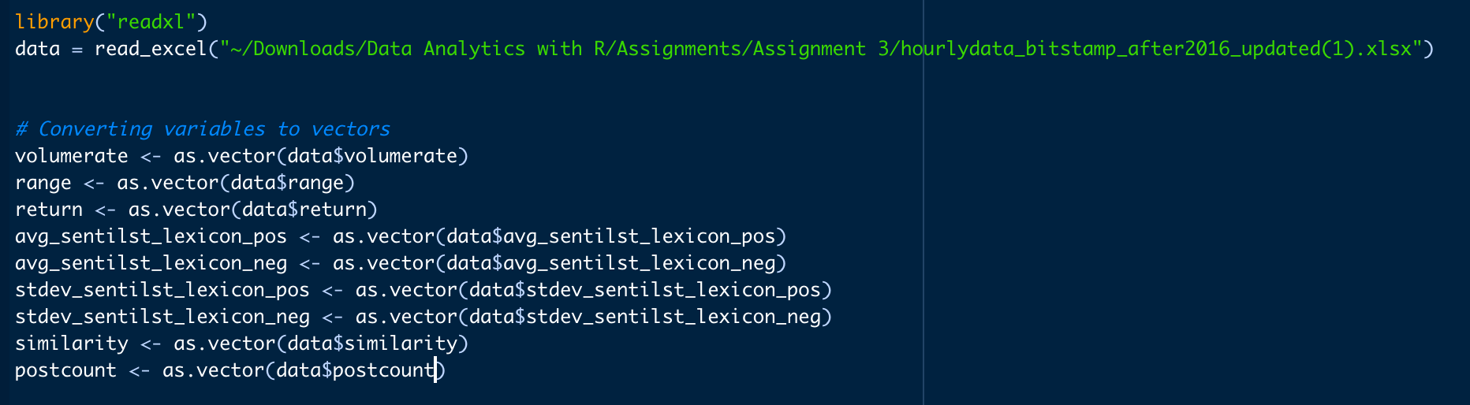

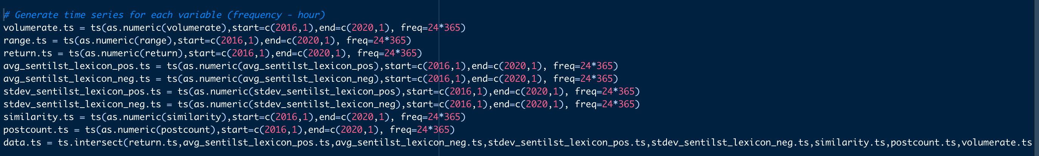



**Output:**

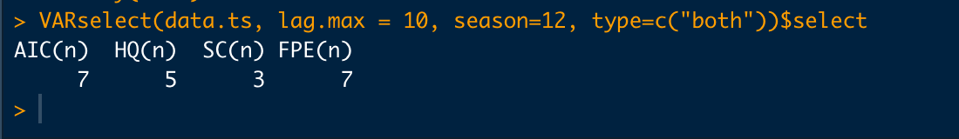

1. What are the eigenvalues of the VAR companion matrix? Is the VAR process stable?

**Answer: Input**

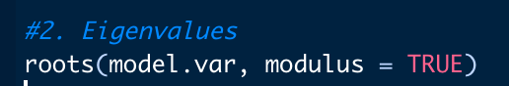

**Output:**



**Since the modulus of each Eigen value is smaller than 1, the VAR process is stable.**

1. Does the negative sentiment and positive sentiment predict Bitcoin returns? Use Granger causality analysis todraw inference. Use 5% as the significance level.

**Answer: Input**



**Output:**

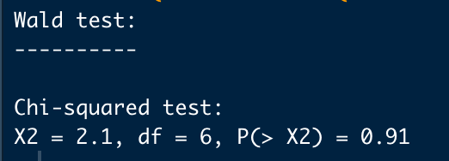

**Since the P** **value is not significant, the negative and positive sentiment does not predict Bitcoin.**

1. Do the Bitcoin returns predict social media negative sentiment and positive sentiment? Use Granger causality analysis to draw inference. Use 5% as the significance level.

**Answer: Input**

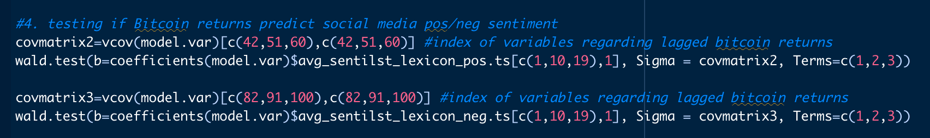

**Output:**

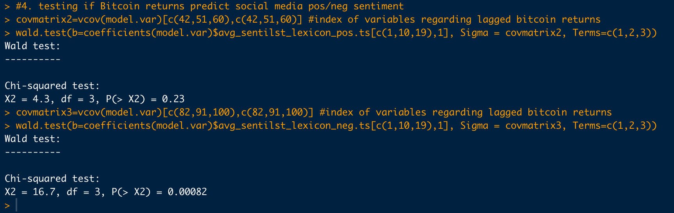

**Since the significant level was considered as 5%, Bit coin returns can only predict negative sentiment (P value = 0.0082) and not the positive sentiment (P value 0.23)**

1. Use the VAR model estimation coefficients to answer what is the direct effect of the Bitcoin returns on the social media negative sentiment during the next hour. The negative sentiment of each message is measured using the percentage of words expressing bearish sentiment.

**Answer:**

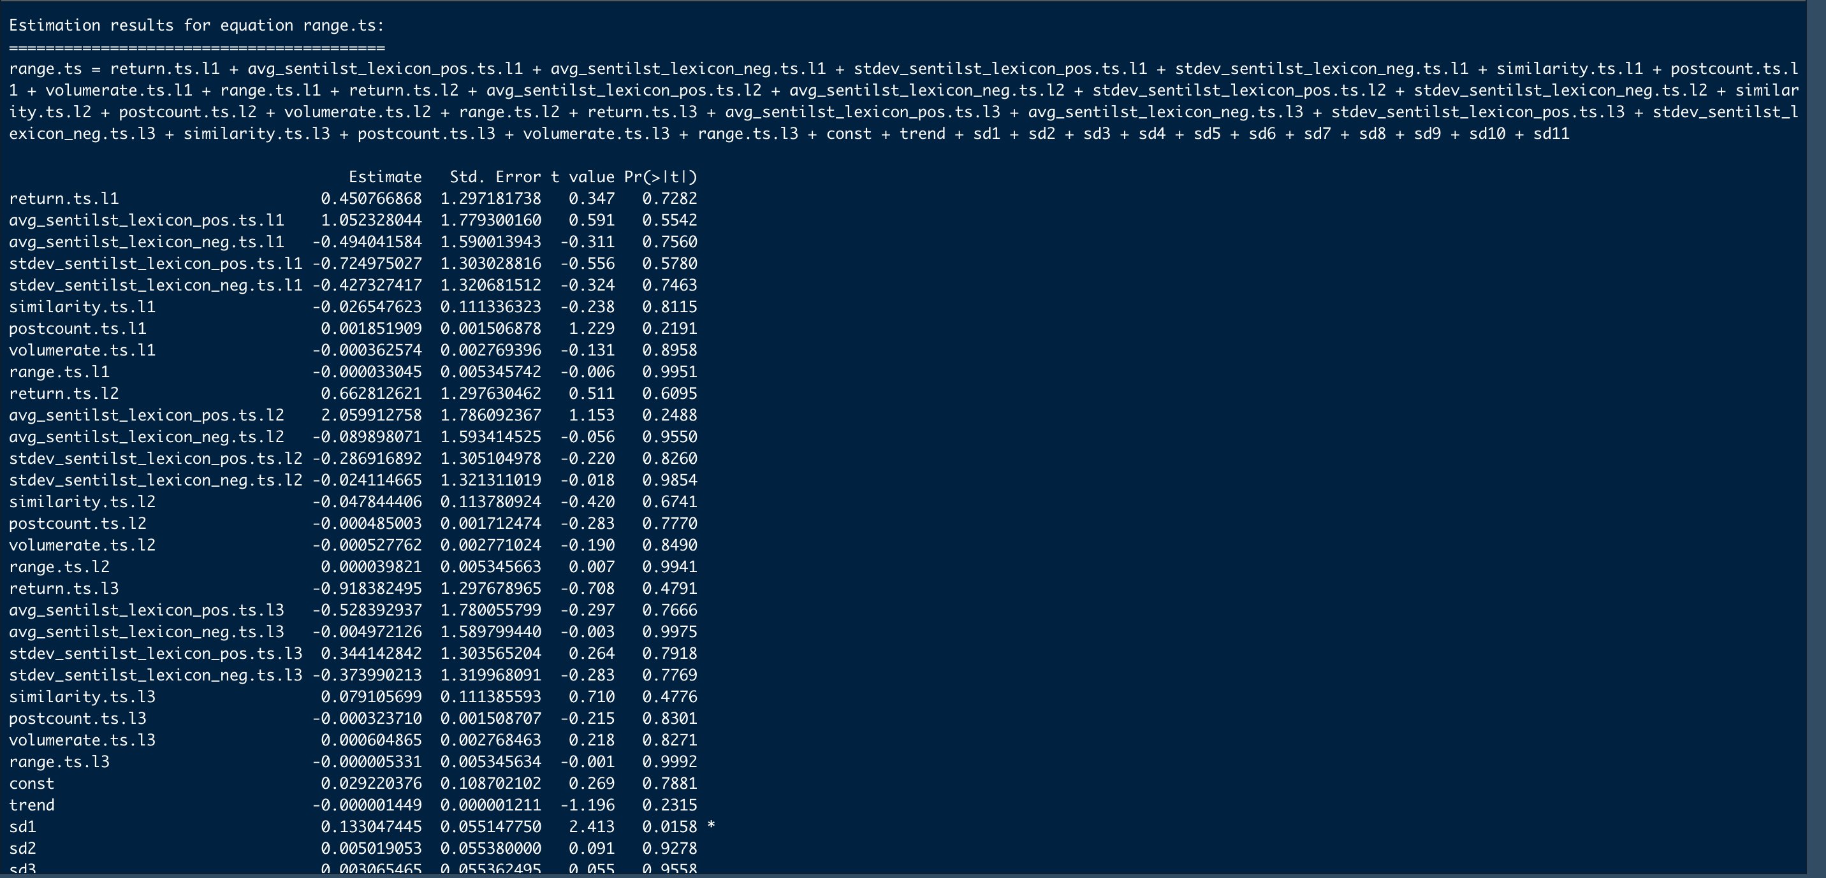

**The coefficient estimation for bitcoin return parameter is negative.**

**Every unit of negative social media sentiment will reduce returns by 0.0169 times.**

1. Do negative Bitcoin returns spark more social media message posting? Use Granger causality analysis to draw inference. Use 5% as the significance level.

**Answer: Input  
**

**Output:**

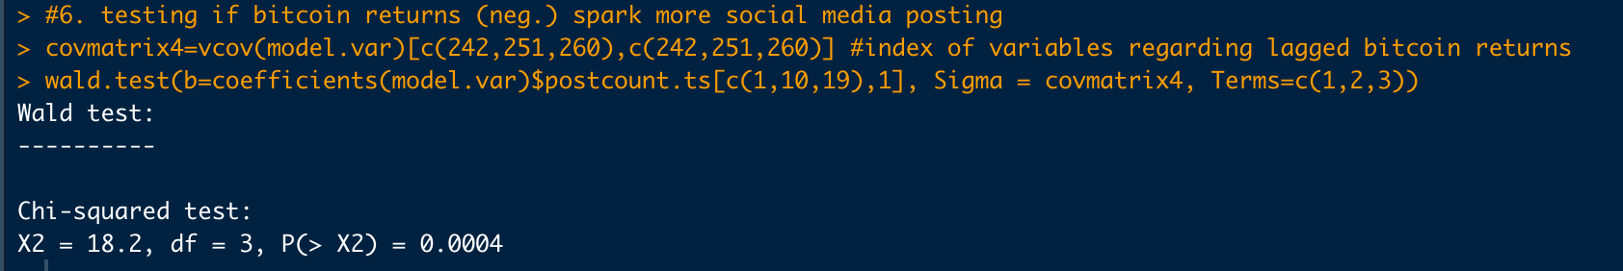

Since the significant level is 5% , Negative bitcoin will returns spark more social media message posting because

T**ask 2**

Import the iris dataset to R studio.

1. Use ggplot2 package to draw a scatter plot between petal length and petal width, color the dots based on the species.

**Answer:** Importing the iris dataset to R studio.

To create a scatter plot between petal length and width using the ggplot2 software, color the dots according to the species.

**Input:**

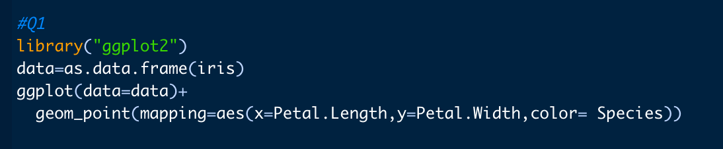

**Output:**

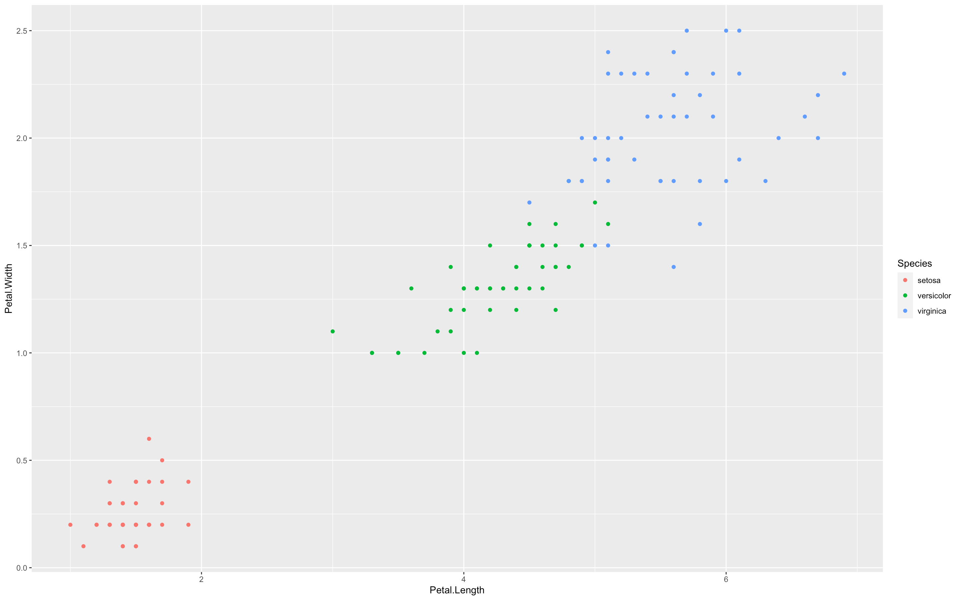

1. Use linear kernel function to train a svm classifier to predict the species based on all explanatory variables.

**Answer: Input**

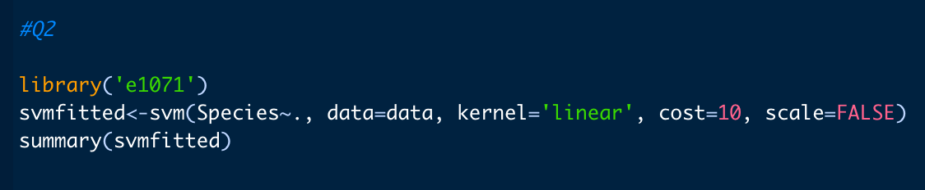

**Output:**

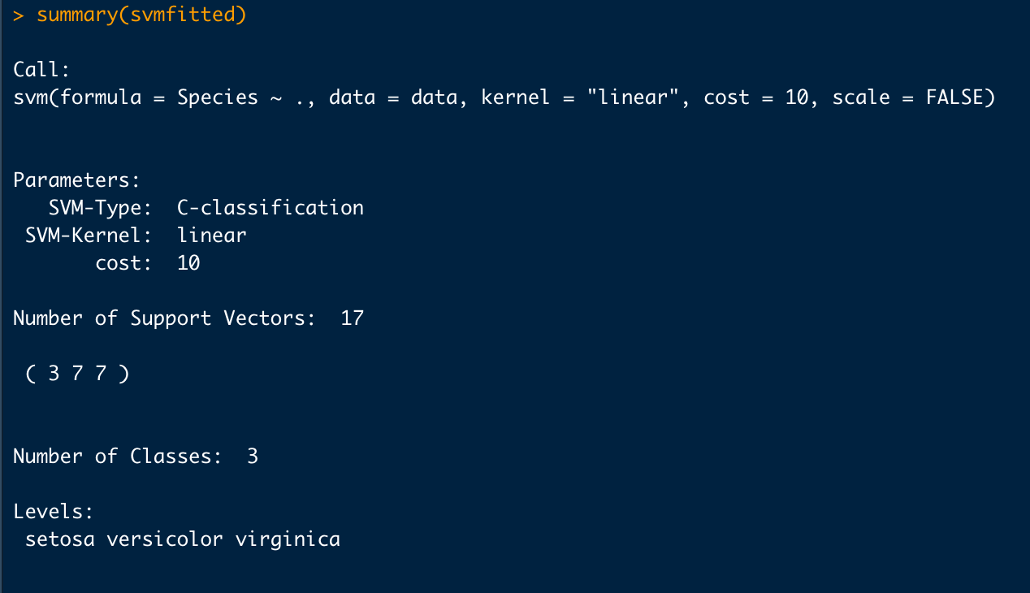

1. Visualize the decision boundary on the surface of petal.width $×$ petal.length given the slice Sepal.Width=3, Sepal.Length=4

**Answer: Input**

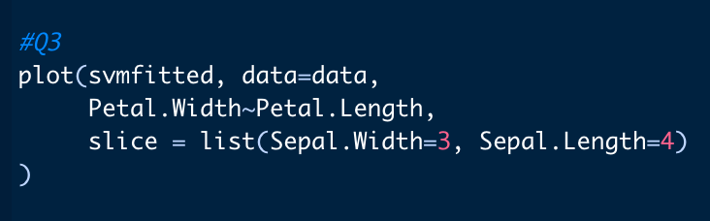

**Output:**

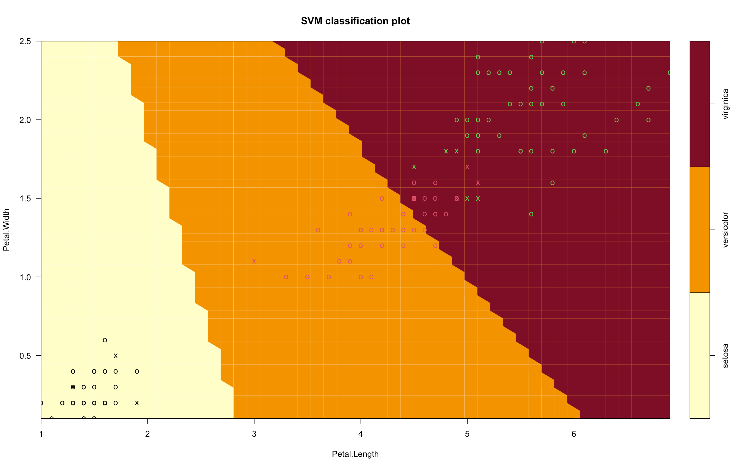

1. Predict the species with the trained model and calculate the prediction accuracy

**Answer: Input**

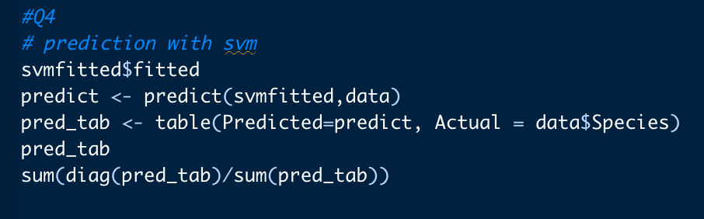

**Output:**

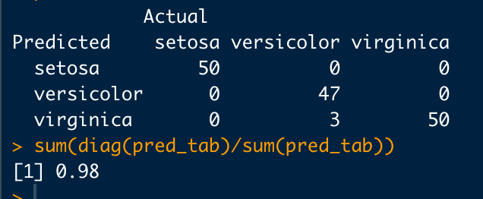

**Accuracy is 98%**

1. Compare a radial kernel with large $γ$ to a radial kernel with small $γ$ (0.1 vs 0.5). Visualize the decision boundary specified in step 3 again. Explain what difference the parameter $γ$ makes.

**Answer: Input**

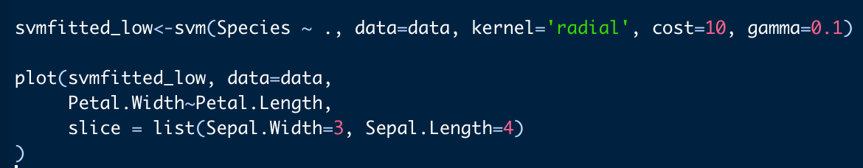

**Output:**

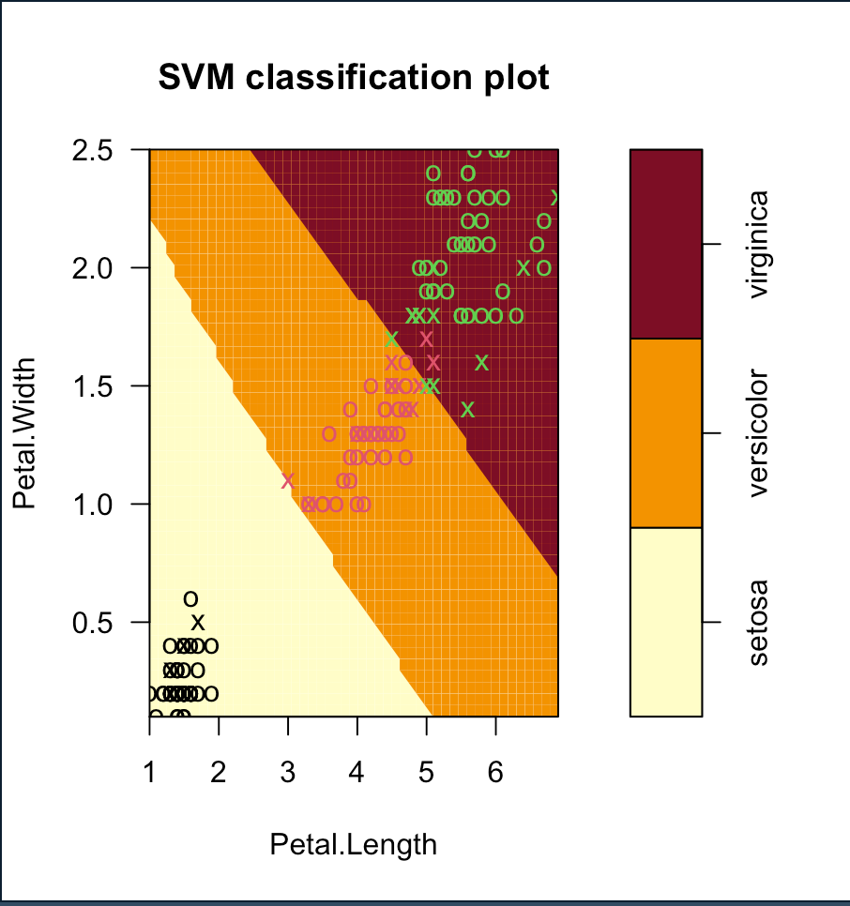

**Input:**

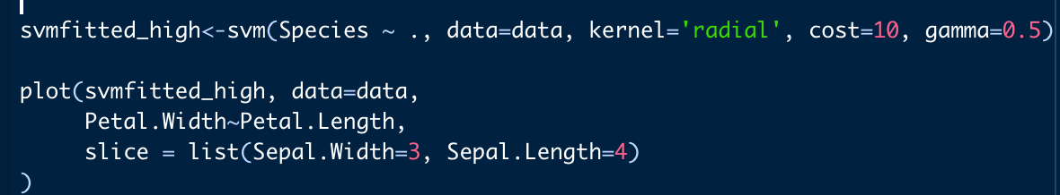

**Output:**

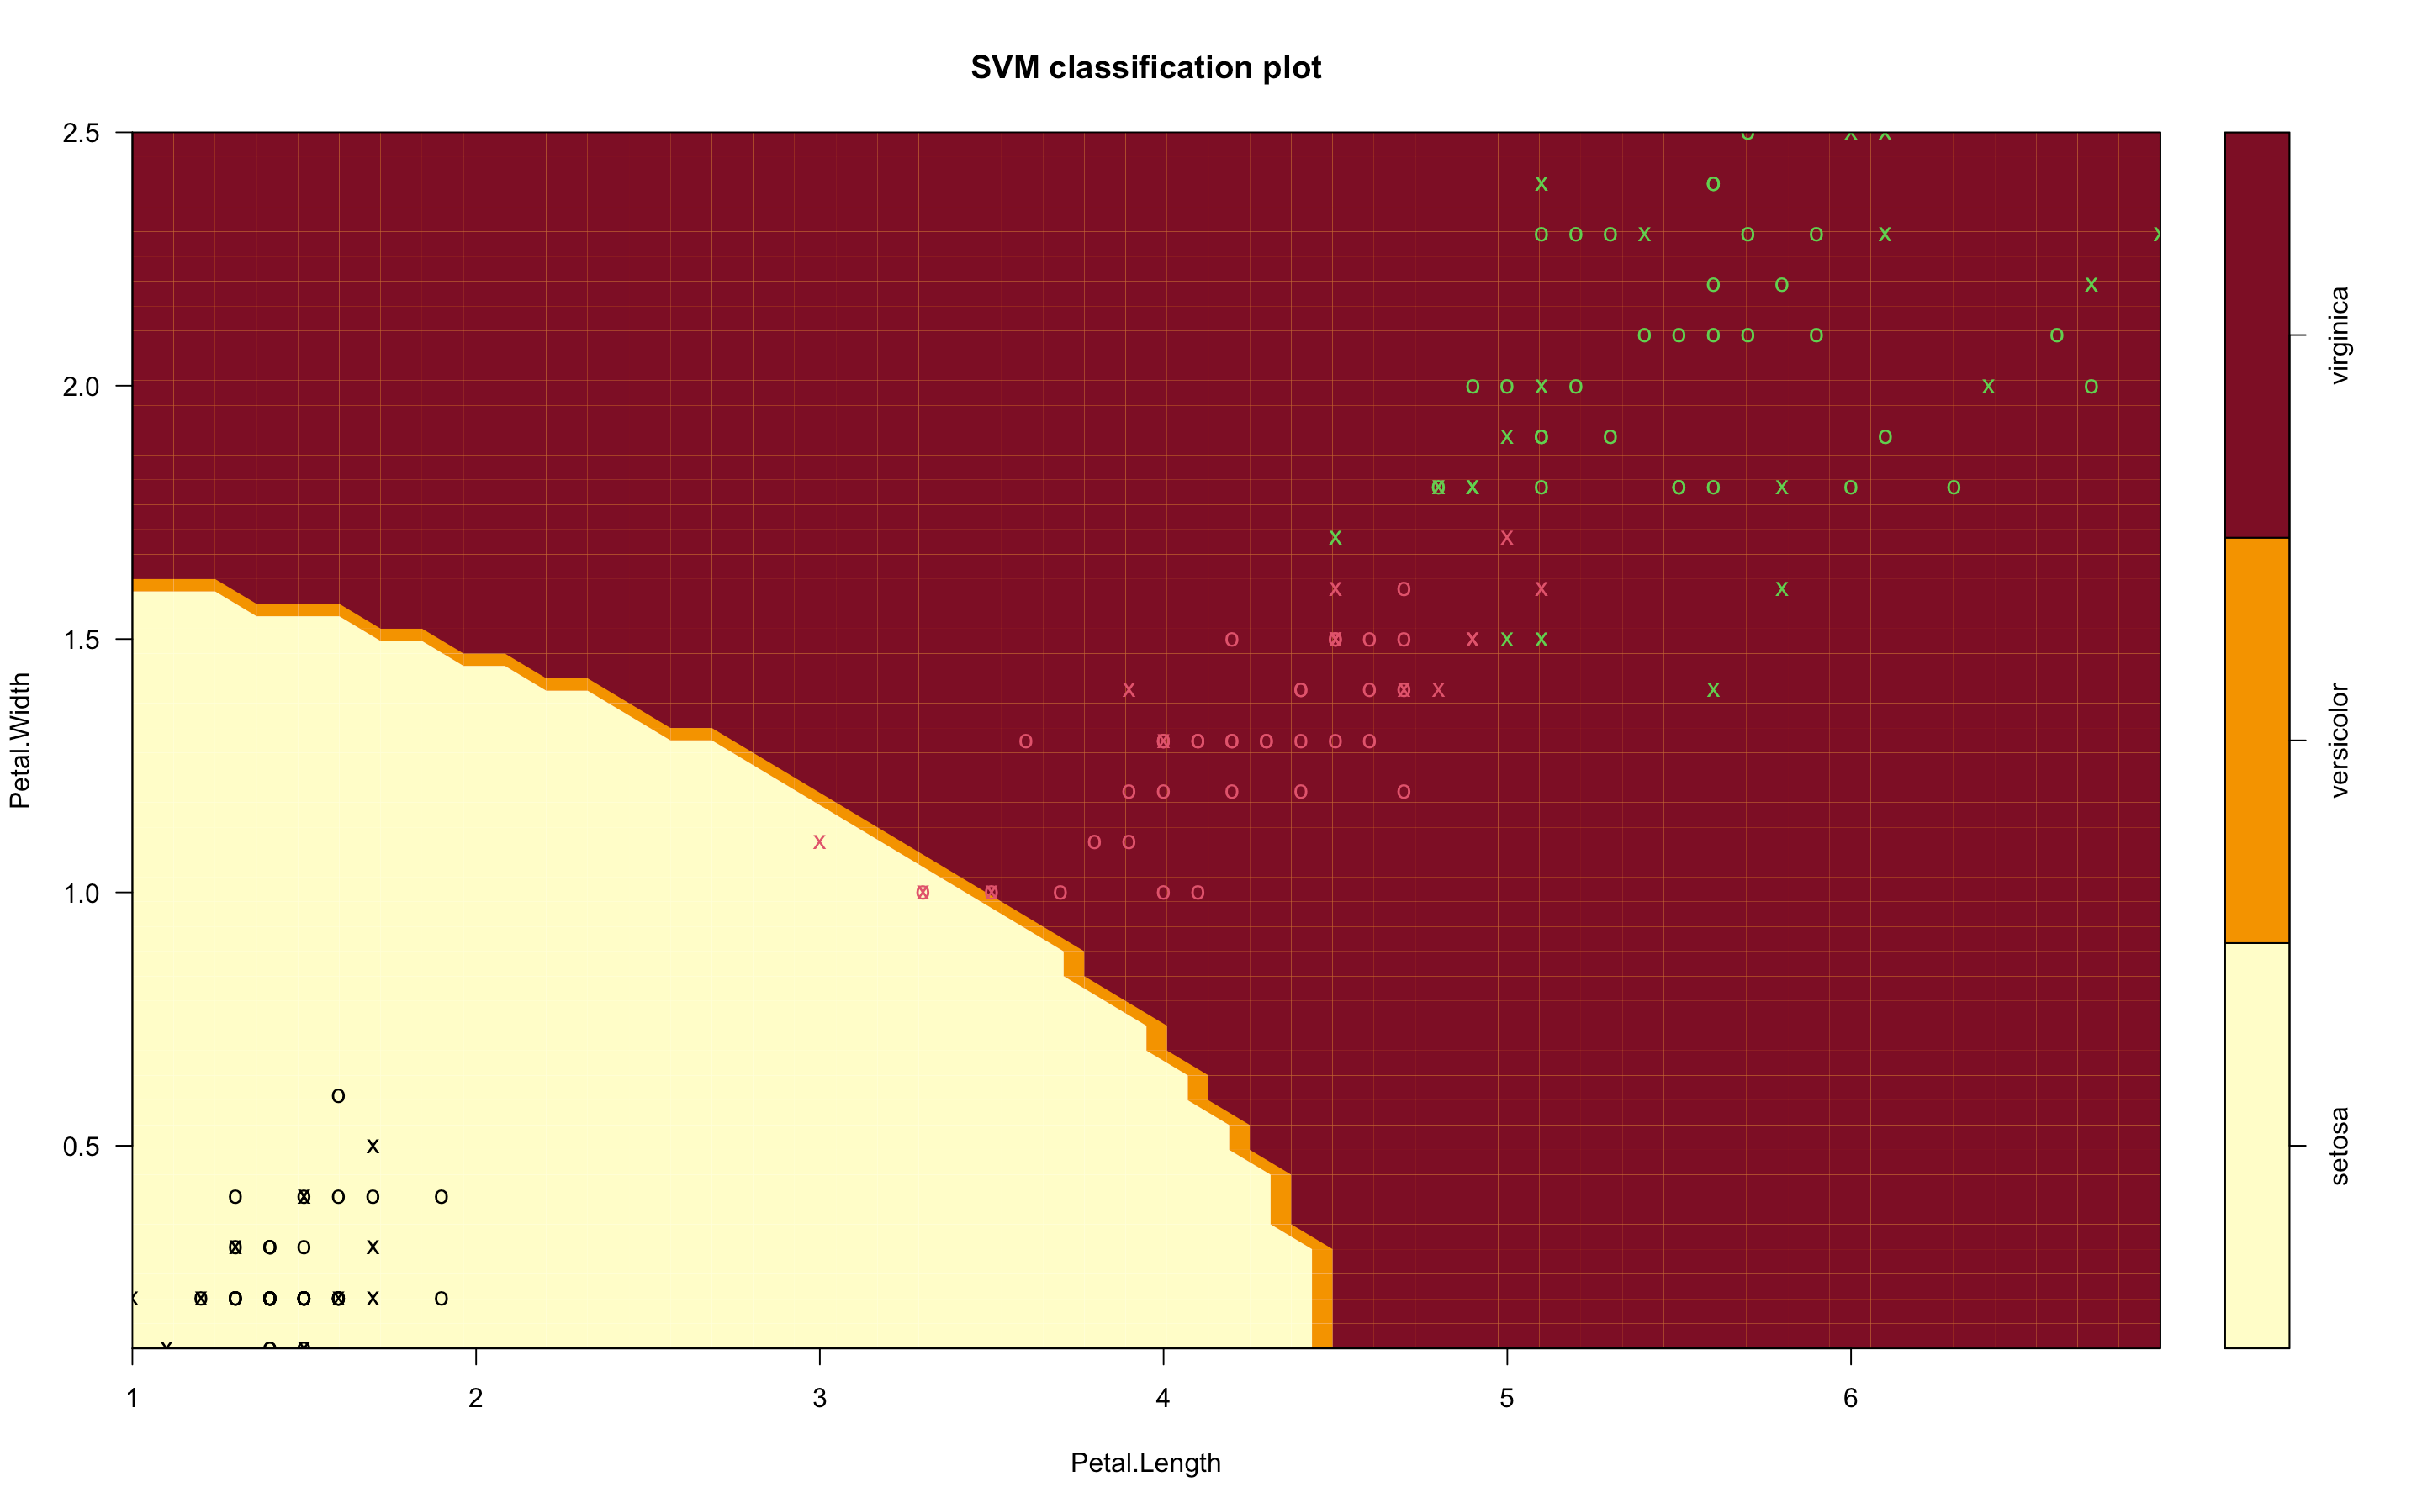

**Lower γ causes underfit and Higher γ causes overfit. In this case we can see that higher γ leads to an increase in incorrect classification of versicolor’ species as ‘virginica’.**

1. Compare a large misclassification cost (100,000) to a small misclassification cost (1). Visualize the decision boundary specified in question 3 again. Explain what difference the cost parameter makes.

**Answer: Input**

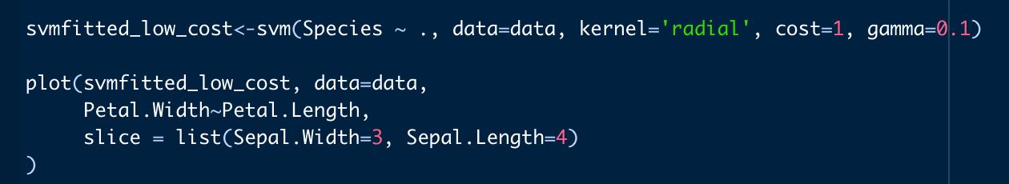

**Output:**

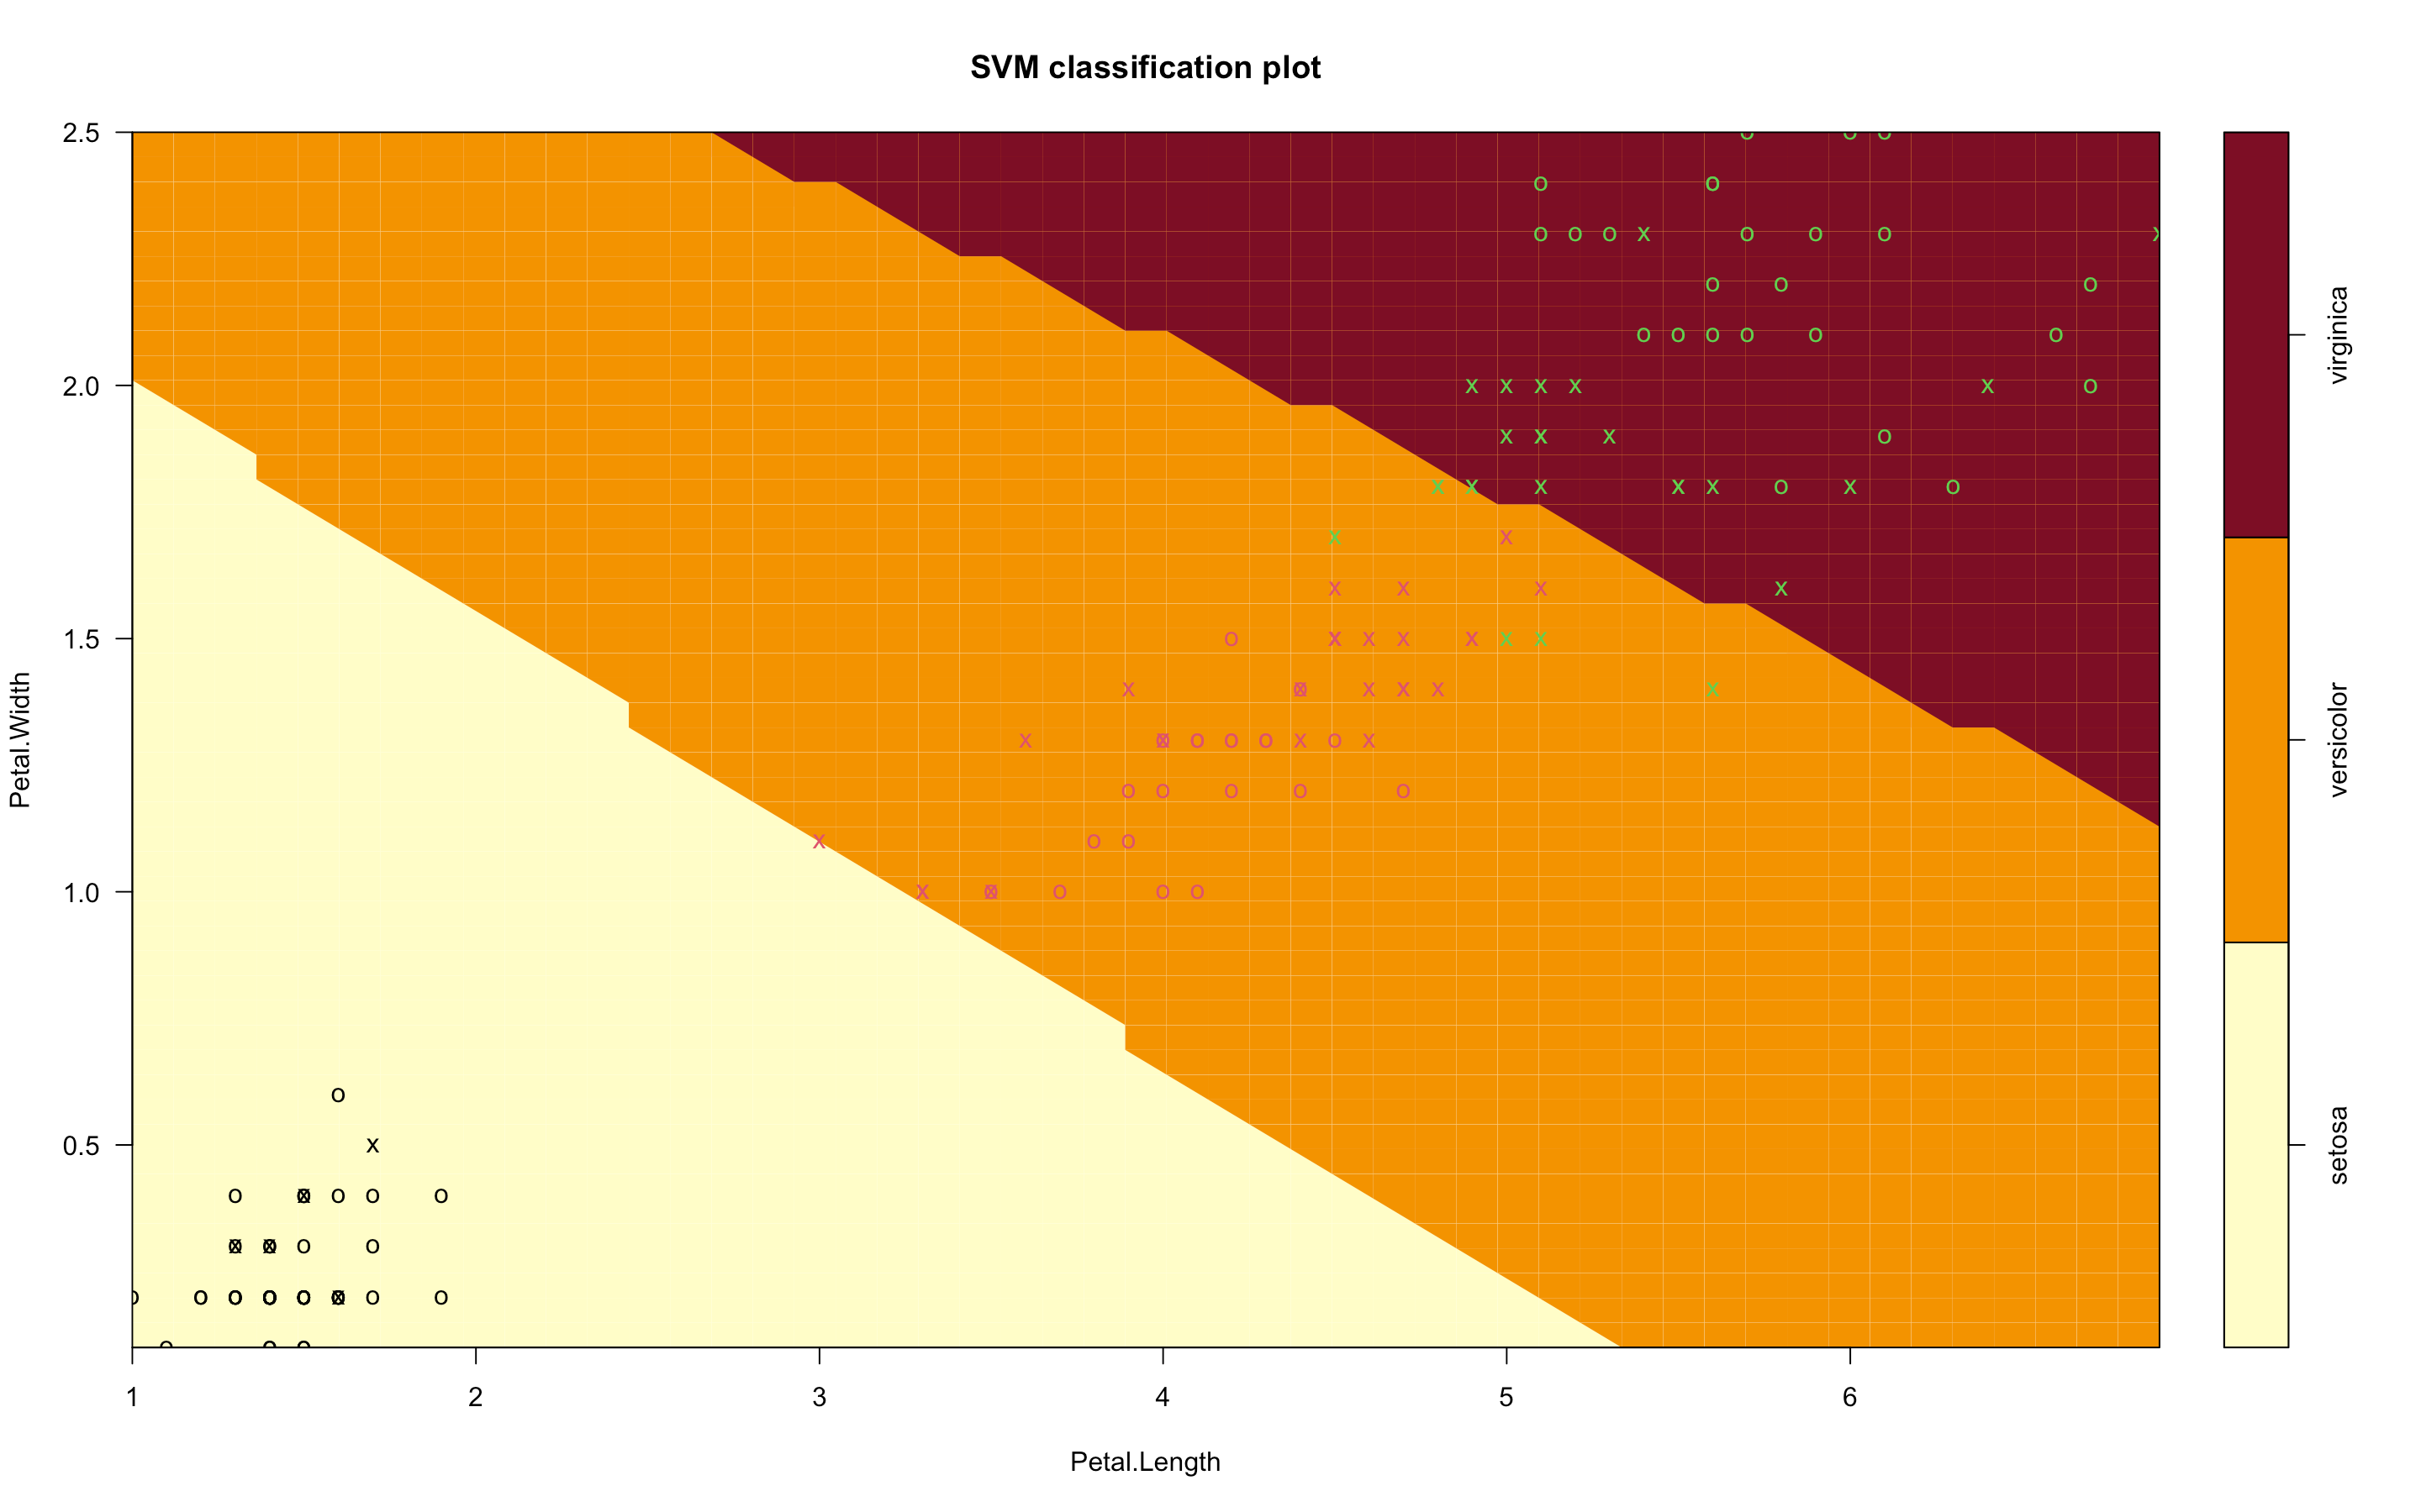

**Input:**

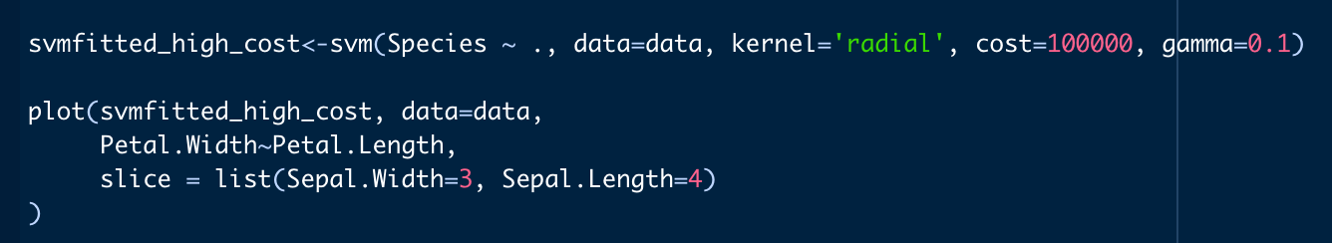

**Output:**

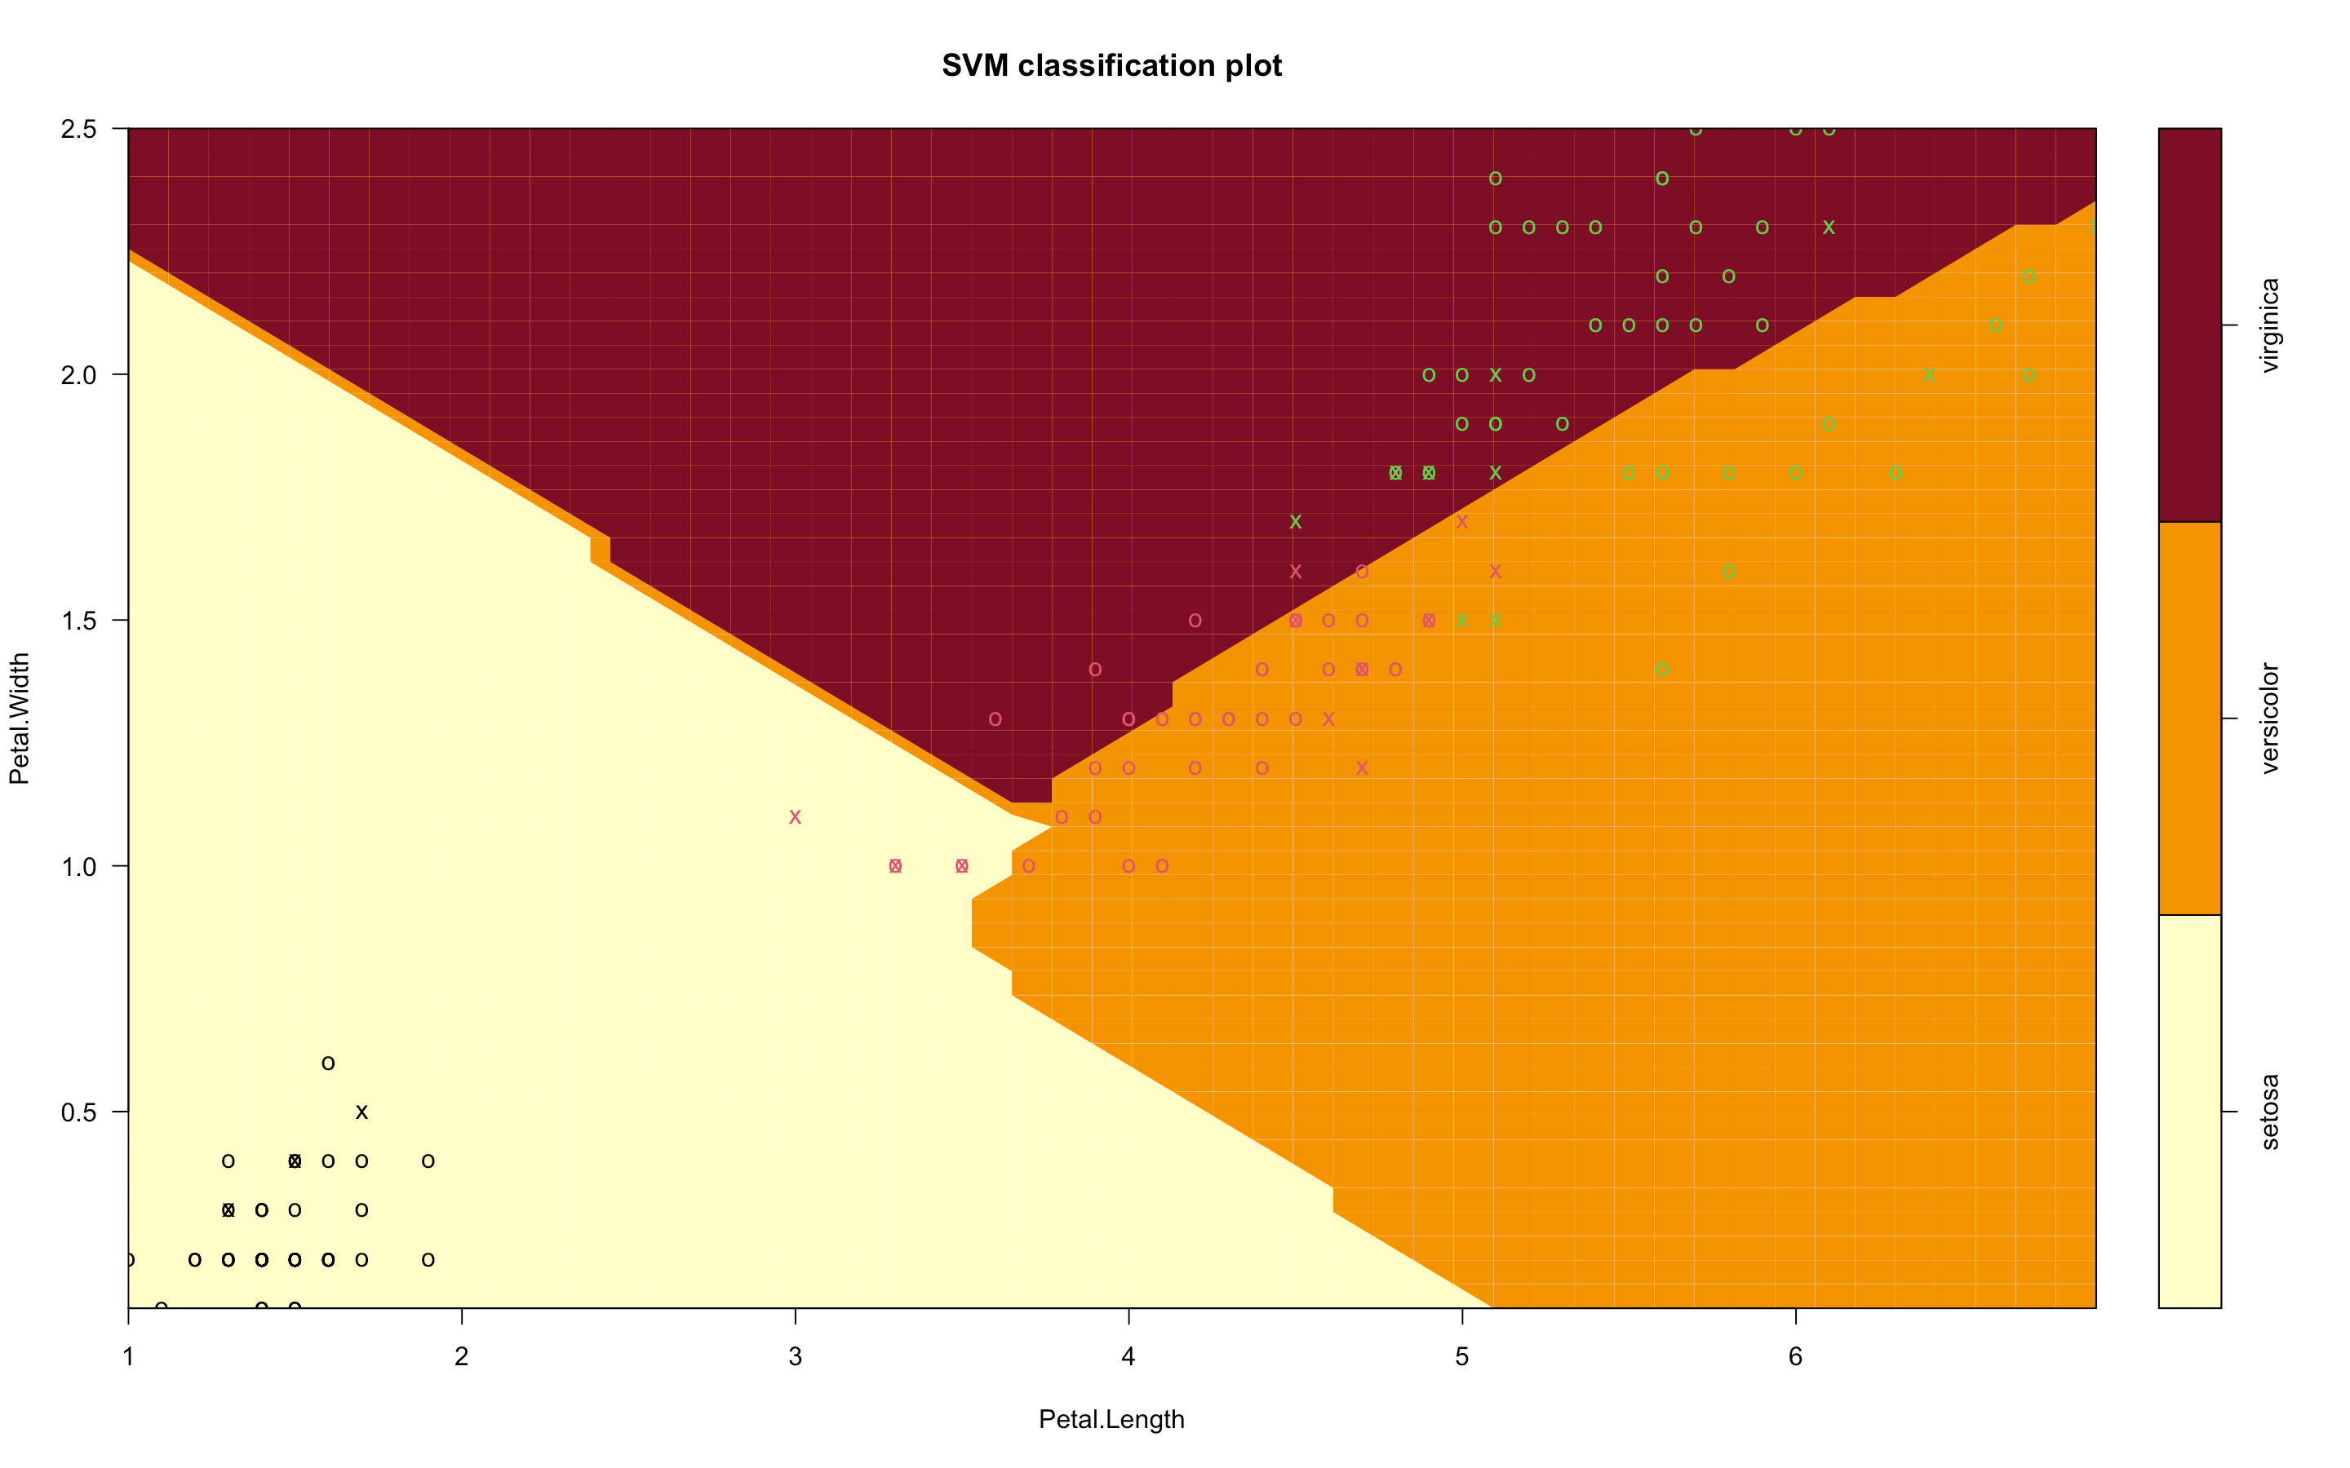

**Since the Cost is low it leads the model to be underfit.   
To escape punishment when costs are high, models often overfit.**

**Task 3**

Following the Naïve Bayes classification example in the slides, please predict if the player go out to play if

1. the outlook is Overcast

2. the temperature is cool

3. the humidity is high

4. not windy

Please show the calculation process just like what we did in class.

**Answer:**

Condition = (Outlook = Overcast, Temperature = cool, Humidity = high, Wind = Not Windy)

Predict the class -> Which probability is bigger

• 𝑃 𝑃𝑙𝑎𝑦 = 𝑌𝑒𝑠 𝐶𝑜𝑛𝑑𝑖𝑡𝑖𝑜𝑛 ≥ 𝑃 𝑃𝑙𝑎𝑦 = 𝑁𝑜 𝐶𝑜𝑛𝑑𝑖𝑡𝑖𝑜𝑛 , 𝑐𝑙𝑎𝑠𝑠 = 𝑌𝑒𝑠

• 𝑃 𝑃𝑙𝑎𝑦 = 𝑌𝑒𝑠 𝐶𝑜𝑛𝑑𝑖𝑡𝑖𝑜𝑛 ≤ 𝑃 𝑃𝑙𝑎𝑦 = 𝑁𝑜 𝐶𝑜𝑛𝑑𝑖𝑡𝑖𝑜𝑛 , 𝑐𝑙𝑎𝑠𝑠 = 𝑁𝑜

Yes Condition:

P(Play = Yes| Condition) = P(Play = Yes, Condition) / P(Condition)

P(Condition) = P(Outlook = Overcast) * P(Temperature = cool) * P(Humidity = High) * P(Wind = Not strong) = (4/14) * (4/14) * (7/14) * (8/14) = 0.0233

P(Play = Yes, Condition) = P(Condition |Play = Yes) * P(Play = Yes) =

P(Outlook = Overcast | Play = Yes) * P(Temperature = cool | Play = Yes) * P(Humidity = High | Play = Yes) * P(Wind = Not strong | Play = Yes) * P(Play = Yes) = (4/9) * (3/9) * (3/9) * (6/9) * (9/14) = 0.0211

Therefore,

P(Play = Yes| Condition) = P(Play = Yes, Condition) / P(Condition)

P(Play = Yes| Condition) = 0.0211 / 0.0233 = 0.9055

No Condition:

P(Play = No| Condition) = P(Play = No, Condition) / P(Condition)

P(Condition) = P(Outlook = Overcast) * P(Temperature = cool) * P(Humidity = High) * P(Wind = Not strong) = (4/14) * (4/14) * (7/14) * (8/14) = 0.0233

P(Play = No, Condition) = P(Condition |Play = No) * P(Play = No) =

P(Outlook = Overcast | Play = No) * P(Temperature = cool | Play = No) * P(Humidity = High | Play = No) * P(Wind = Not strong | Play = No) * P(Play = No) = (0/5) * (1/5) * (4/5) * (2/5) * (5/14) = 0

Therefore,

P(Play = No| Condition) = P(Play = No, Condition) / P(Condition) = 0

**So the predicted class is play = Yes**

**Task 4**

Please import the “admit.csv” into Rstudio. In this dataset, we know the GRE score, the GPA, and the rank of 400 applicants for a graduate program. We also know if each of the candidates is admitted. In the admit column, 1 stands for “admitted”, and 0 stands for “rejected”. We are going to do clustering based on GRE and GPA for these applicants. Do not forget to standardize the dataset before clustering.

**Answer: Input:**

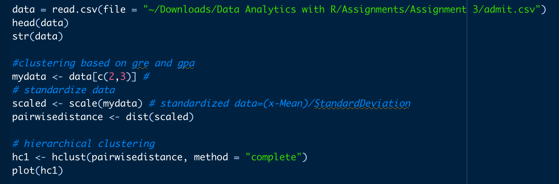

Please do hierarchical clustering using complete link method. If you want only two clusters, what cluster is the 4th applicant in?

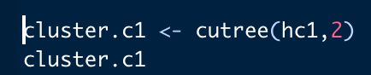

**The 4th applicant is in Cluster 1**

If you want three clusters, what cluster is the 4th applicant in?

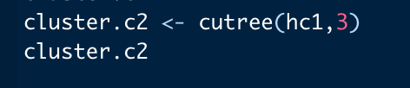

**The 4th applicant is in Cluster 2**

**Output:**

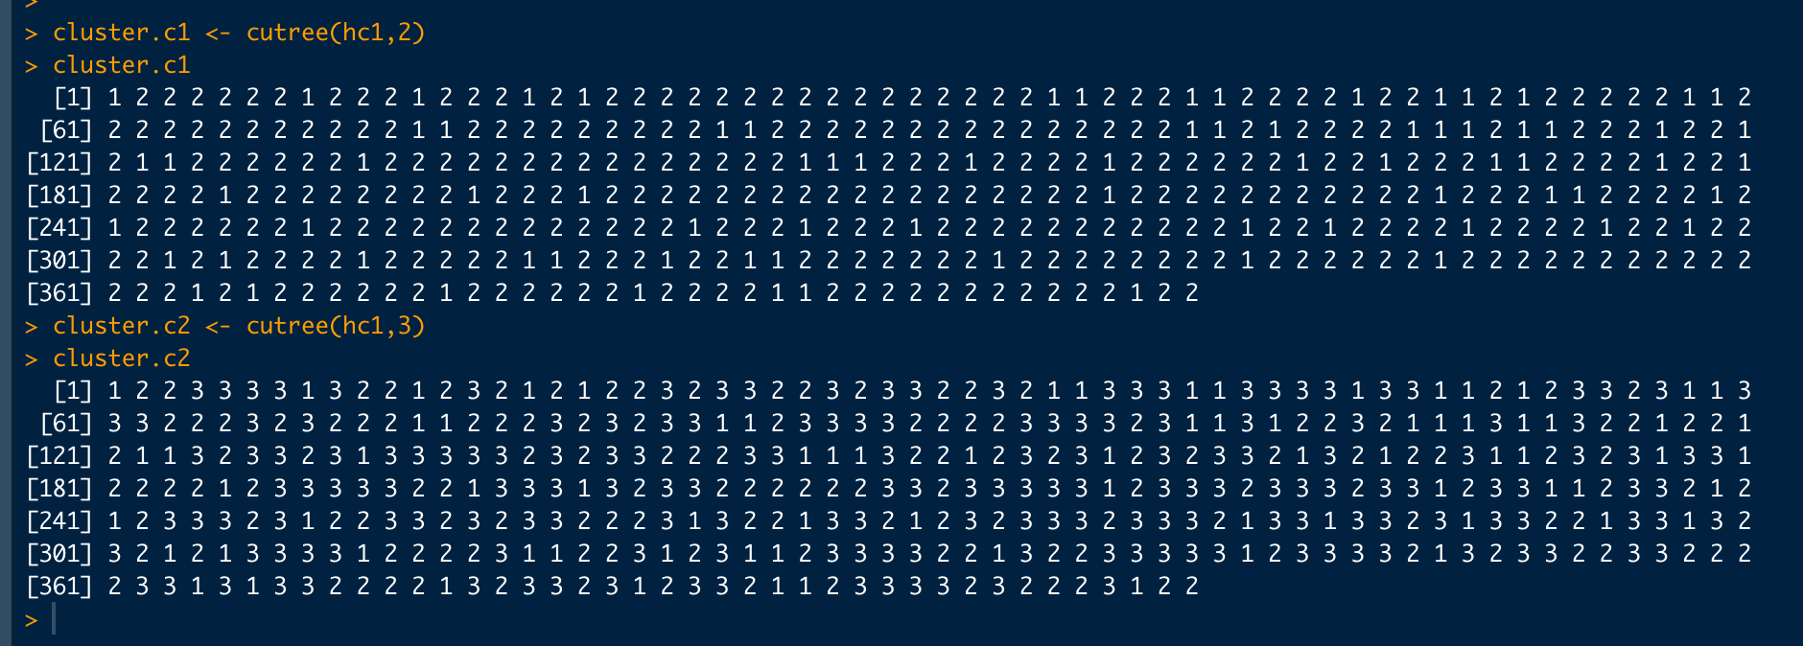

Please show the codes while answer the questions.

**Task 5**

Please import the “admit.csv” into Rstudio. In this dataset, we know the GRE score, the GPA, and the rank of 400 applicants for a graduate program. We also know if each of the candidates is admitted. In the admit column, 1 stands for “admitted”, and 0 stands for “rejected”. Please answer the following questions and include the codes.

1. Import the dataset and call it "mydata". Then check the structure of the data (the str method)

**Answer: Input**

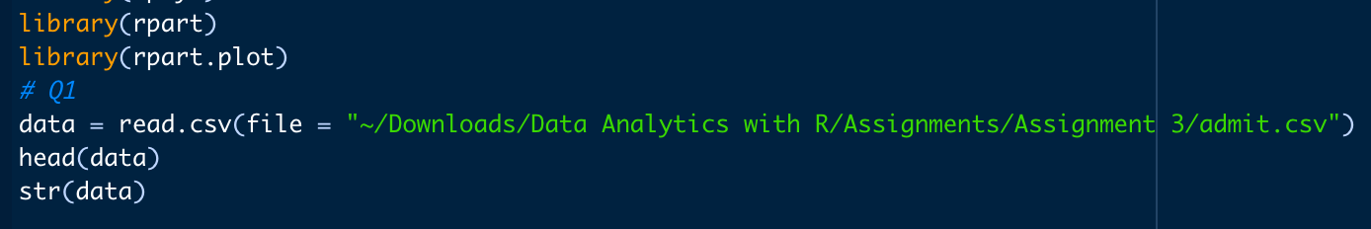

**Output:**

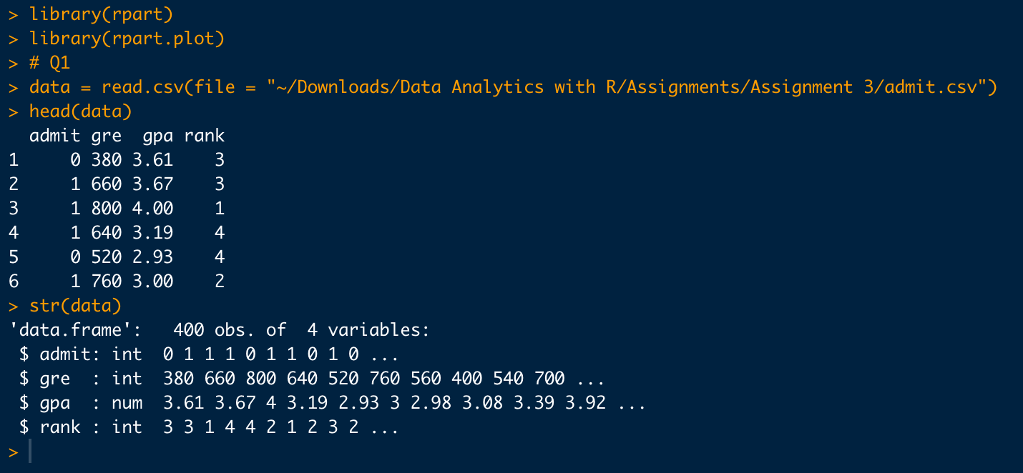

2. convert the data type of the admit and the rank column from int to factors

**Answer: Input**

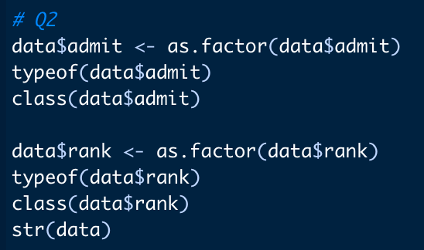

**Output:**

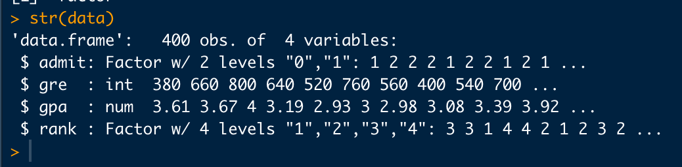

3. randomly select 80% of the dataset as training set and the rest as the testing set

**Answer:**

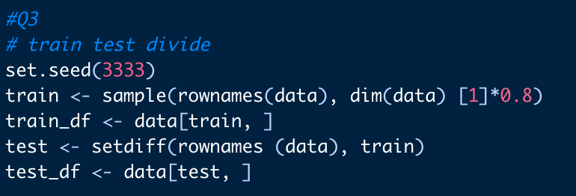

4. train a decision tree model, using admit as the category, and gre, gpa, and rank as predictors. Then plot the tree

**Answer: Input**

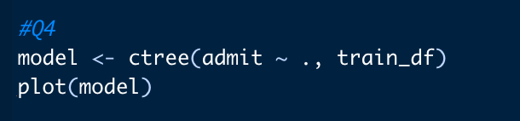

**Output:**

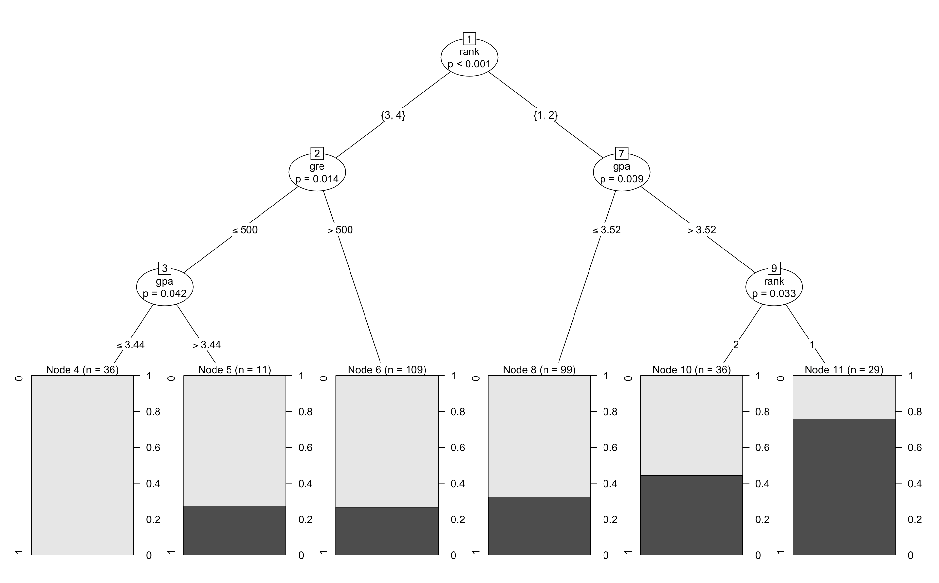

5. Please answer the question: if a candidate has a GPA of 3.7, and rank of 4, does this candidate have a higher chance to be admitted or to be rejected? Please note that when you only have two categories, the darker proportion stands for the proportion for 1 in the end node of the tree plot

**Answer:** GPA – 3.7

Rank 4

Assuming the score = 500

Therefore, class = 0

So there is 80% chance of being rejected (Node 5)

6. Please calculate the accuracy of your decision tree model

**Answer: Input**

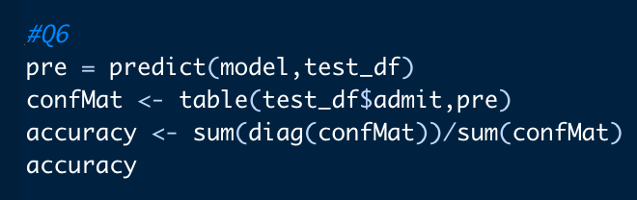

**Output:**

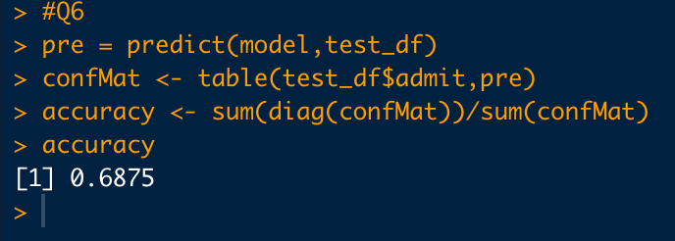

**The Accuracy is 68.75%**

**Task 6**

REI, a national outdoor sport gear retailer, is trying to revamp the layout of its stores to make them more efficient and to help customers locate the desired merchandise with more ease. Moreover, REI is also trying to woo more customers in with bundled offers (multiple products grouped together for one price). For both undertakings, REI must understand what items customers tend to buy together. You have been recently hired by REI as a data analyst / statistician to help them with a market basket analysis.

Please download the Market Basket.csv. You will find REI’s sales scanner data that traces 12 products over 100 transactions. Below is a list of the item names and their abbreviation.

|  |  |  |
| --- | --- | --- |
| Kayak ‐ K | Portable Stove ‐ PS | Backpack ‐ BP |
| Tent ‐ T | Ski Goggles ‐ SKG | Sunscreen ‐ SS |
| Flashlight ‐ F | SKG Sunglasses ‐ SG | Swimsuit ‐ SW |
| Snowboard ‐ SNB | Sleeping Bag ‐ SB | Running Shoes ‐ R |

1. Import the Data Please import the data set to R studio using read.csv. mydata=read.csv("……/market basket.csv",header=TRUE)

**Answer: Input**



**Output:**

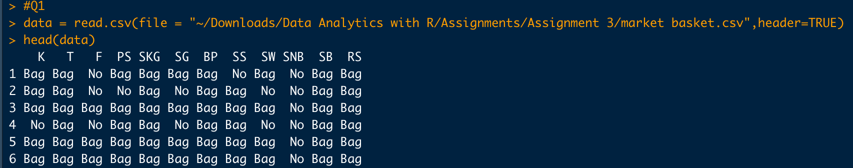

1. Please summarize the data using summary(the dataset name) and copy the R outputs to the answer sheet

**Answer: Input**

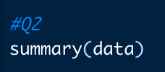

**Output:**

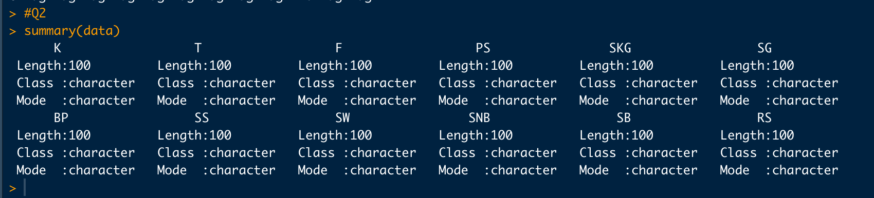

1. Do a rule mining using Apriori with default parameters. Important: don't inspect rules. It will take a lot of time. Answer how many rules you got.

**Answer: Input**

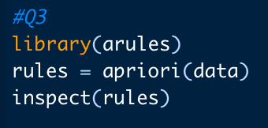

**Output:**

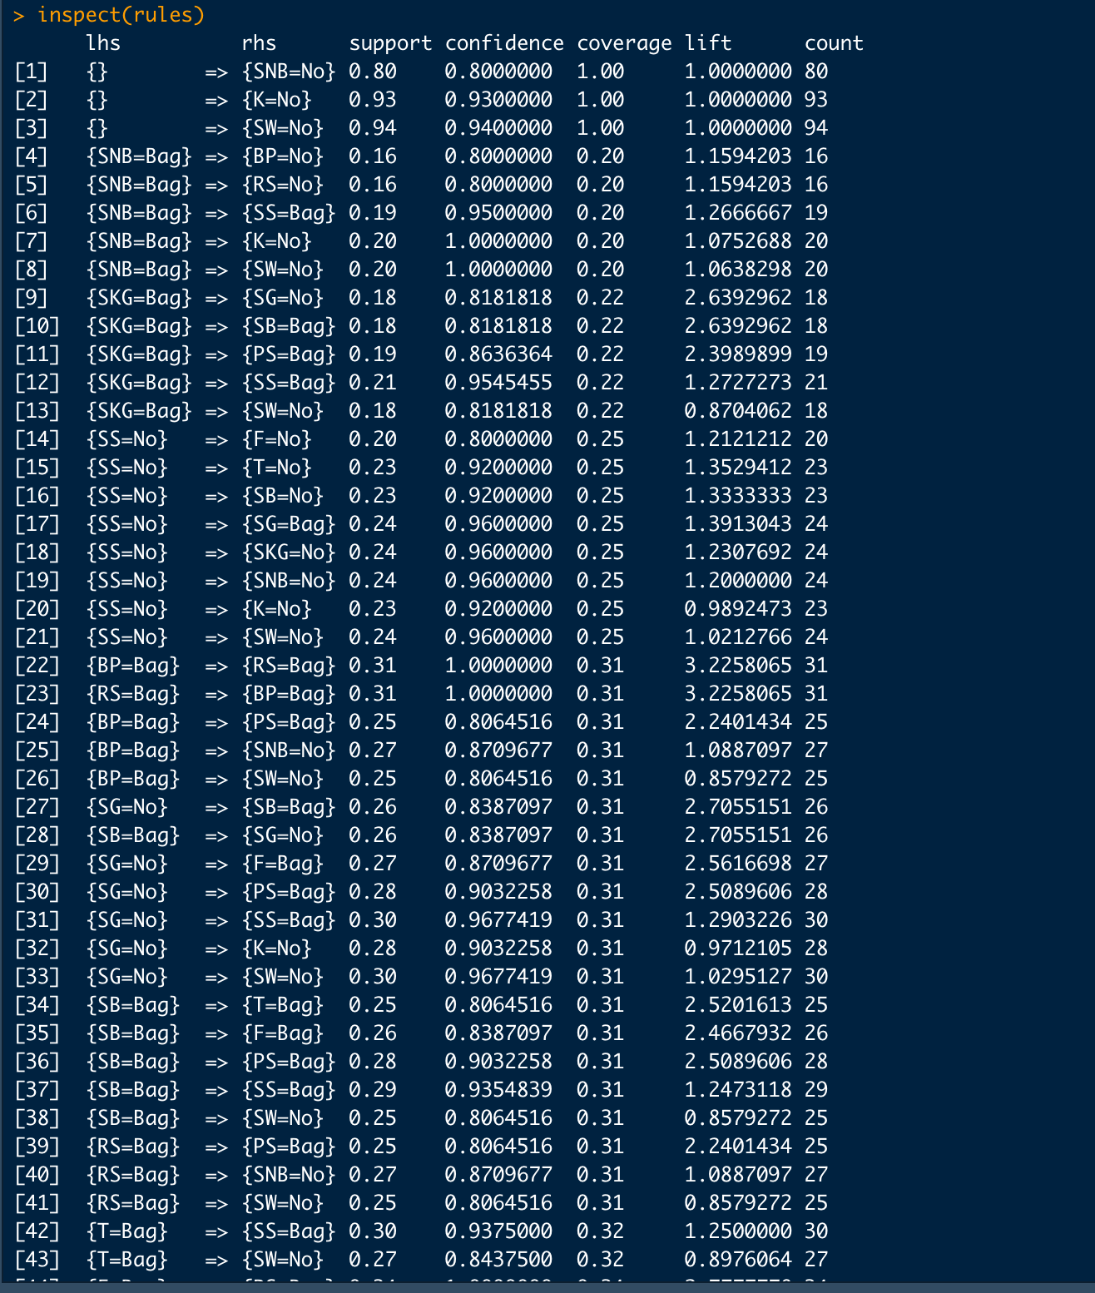

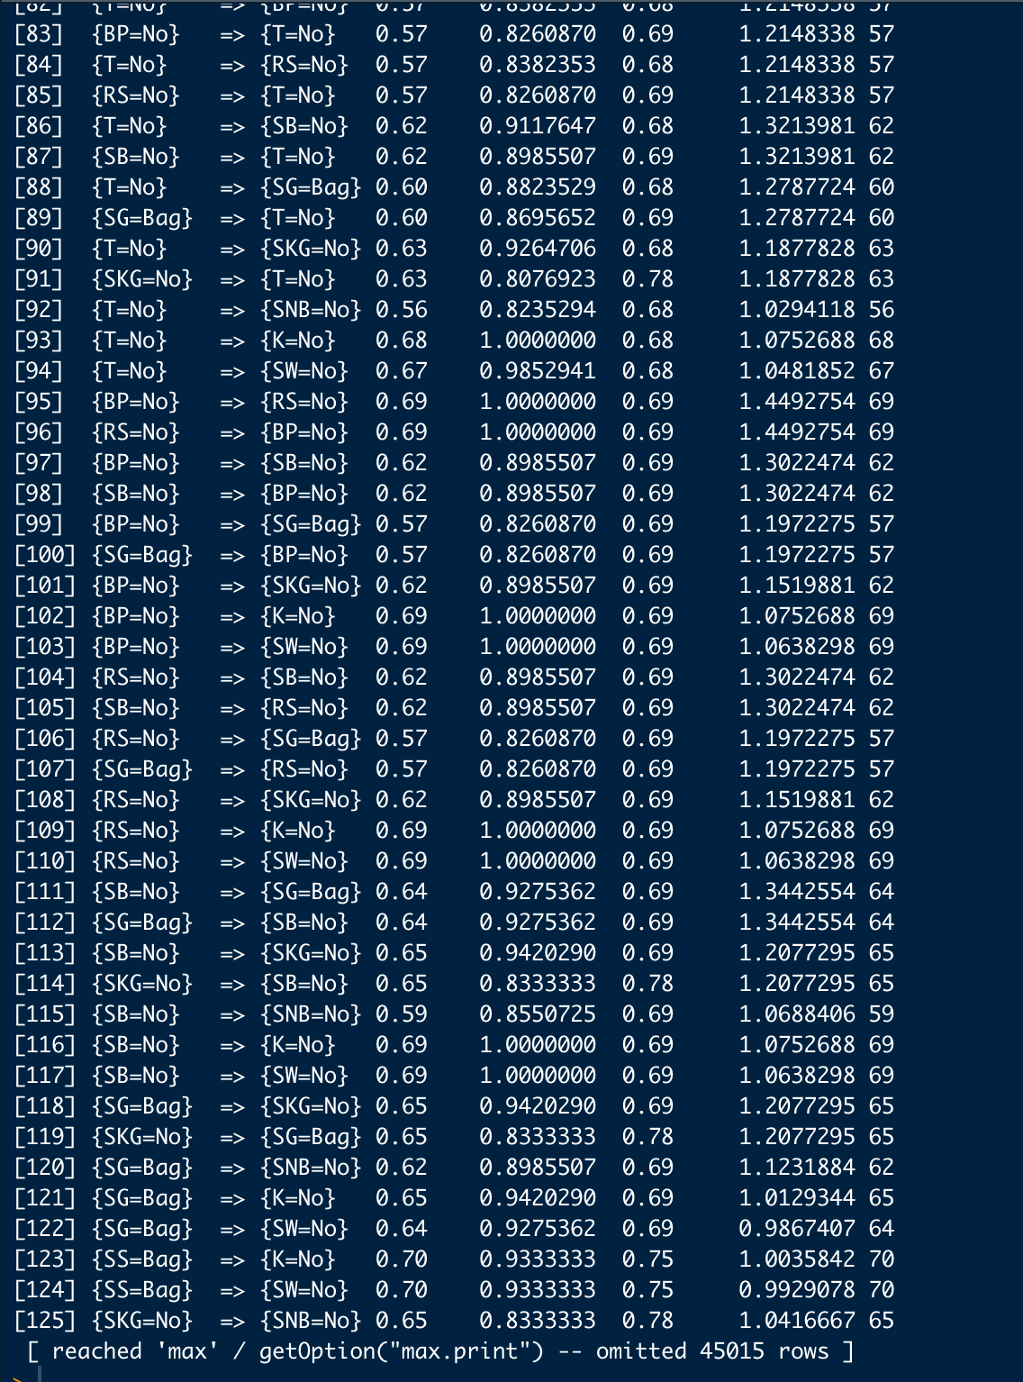

1. Now limit the parameters to minlen=2,supp=0.05,conf=0.7, and limit our attention to the purchase of K (make K purchase as the lhs: appearance=list(lhs=c("K=Bag"),default="rhs")) Inspect the rules and copy the results to your answer sheet.

**Answer: Input**



**Output:**

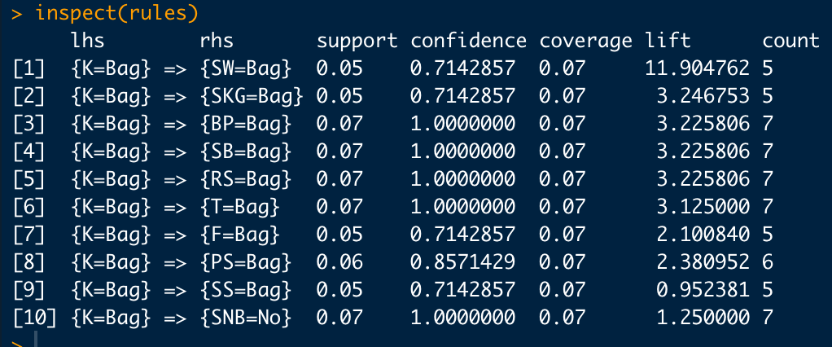

1. What the 3rd rule tells you about (confidence = 1)? What is rule 10? Is it meaningful?

**Answer:** Confidence = 1 for rule 3

There is a 100% likelihood that the consumer will purchase both the kayak and the backpack.

There is no possibility that the buyer would purchase a snowboard and kayak together.

1. Now let's focus on the "Purchasing behavior", but not the "not-purchasing behavior" like the previous rule 10. Keep other parameters the same and use appearance=list(lhs=c("K=Bag"),rhs=c("T=Bag","F=Bag","PS=Bag","SKG=Bag","SG=Bag","BP=Bag","SS=Bag","SW=Bag","SNB=Bag","SB=Bag","RS=Bag"),default="none"). Copy the R outputs to your answer sheet. Which rule has the highest lift?

**Answer: Input**

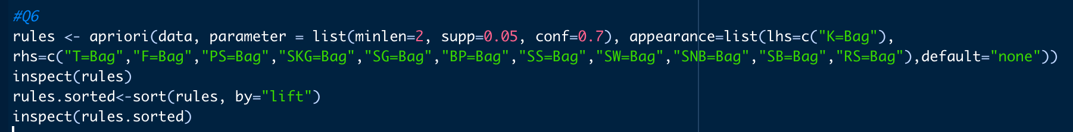

**Output**

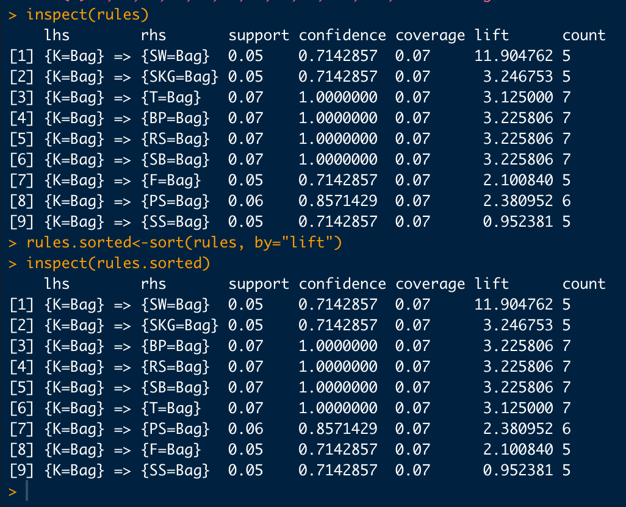

**The rule with highest lift is {K=Bag} => {SS=Bag}**

**This means, the customer who purchases kayak would also purchase swim suit.**

**Task 7**

We are studying the airline customer clustering based on some of their attributes (use the AirlineClustering.csv) listed below:

|  |  |
| --- | --- |
| ID | Unique ID |
| Balance | Number of miles eligible for award travel |
| QualifyMiles | Number of miles counted as qualifying for Topflight status |
| Cc1Miles | Number of miles earned with freq. flyer credit card in the past 12 months: |
| Cc2Miles | Number of miles earned with Rewards credit card in the past 12 months: |
| Cc3Miles | Number of miles earned with Small Business credit card in the past 12 months: |
| BonusMiles12m | Number of miles earned from non-flight bonus transactions in the past 12 months |
| BonusTrans12m | Number of non-flight bonus transactions in the past 12 months |
| FlightMiles12m | Number of flight miles in the past 12 months |
| FlightTrans12m | Number of flight transactions in the past 12 months |
| DaysSinceEnroll | Number of days since Enroll_date |
| PhoneSale | Dummy variable indicating whether member purchased over phone 1=sale, 0=no sale |

Please follow the instructions below:

1. Standardize variable using the scale function (not including PhoneSale)

**Answer: Input**

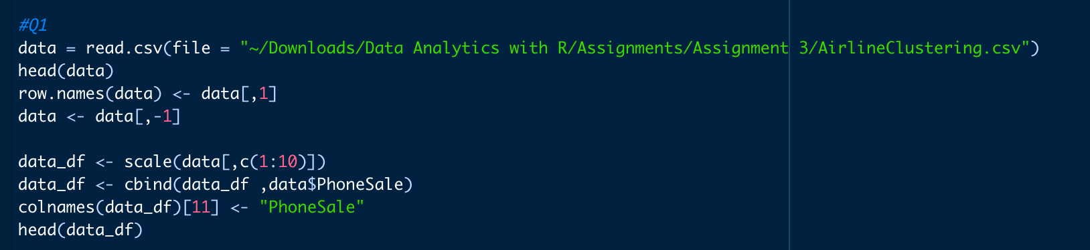

**Output:**

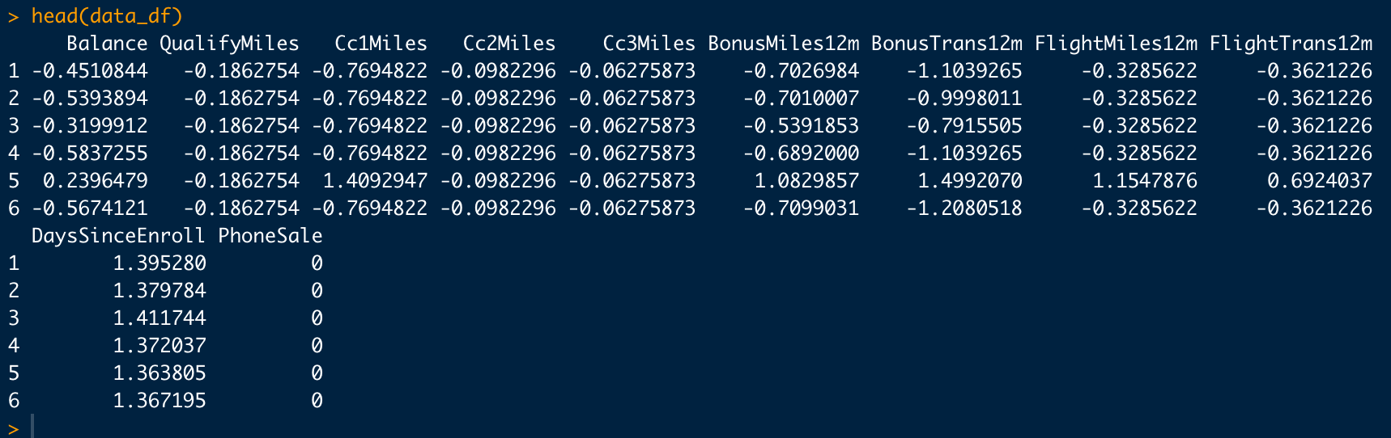

1. Use within cluster sum of squared distance (wss) to determine what is a good number of clusters with k-means method.

**Answer: Input**

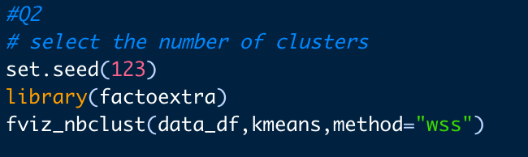

**Output:**

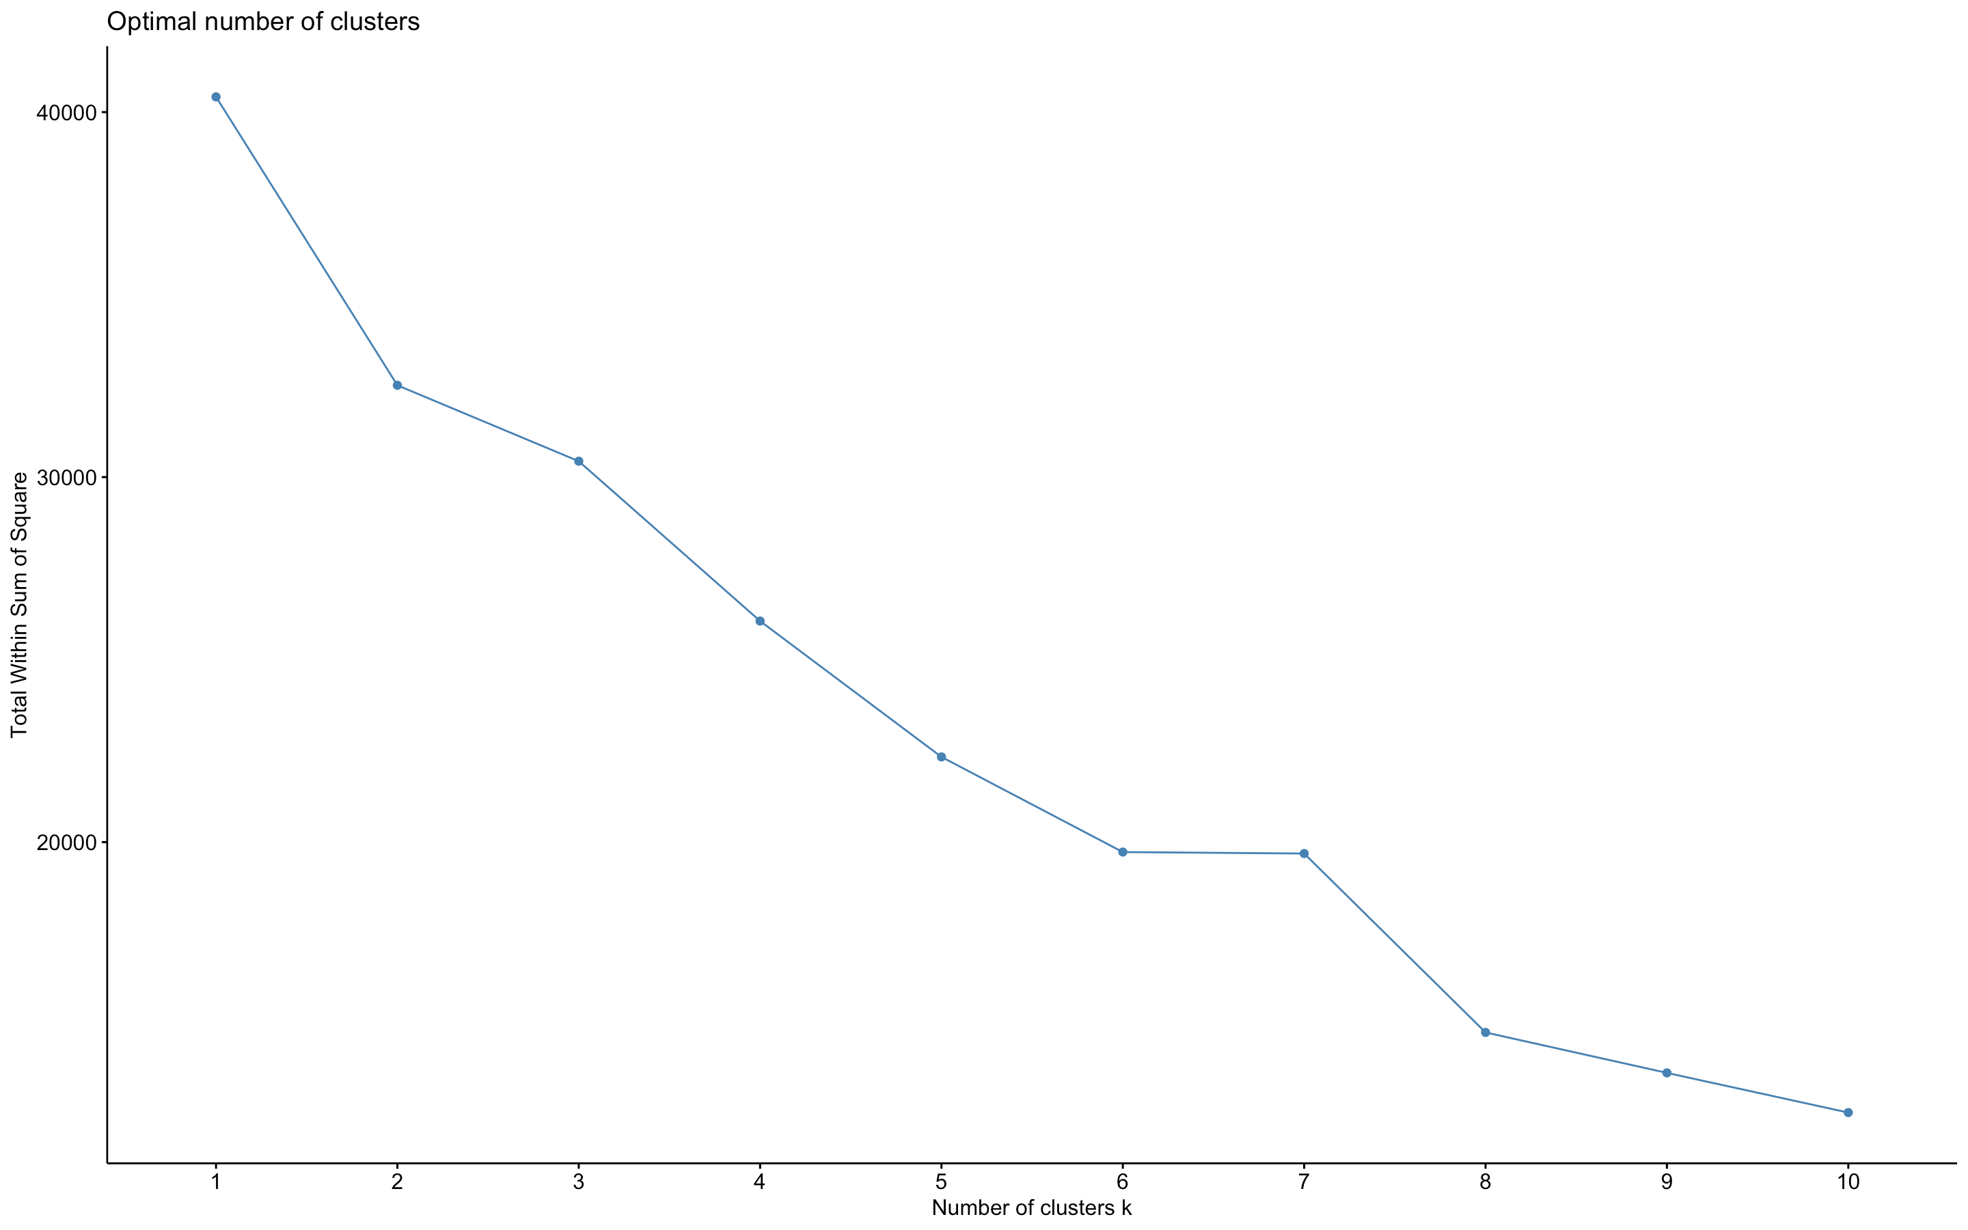

**From the above graph we can see that 6 is the optimal number cluster.**

1. Do a k-means clustering with 25 runs (nstart=25) and show the result

**Answer: Input**

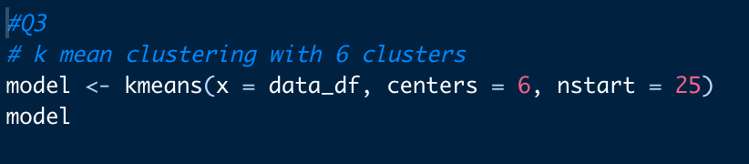

**Output:**

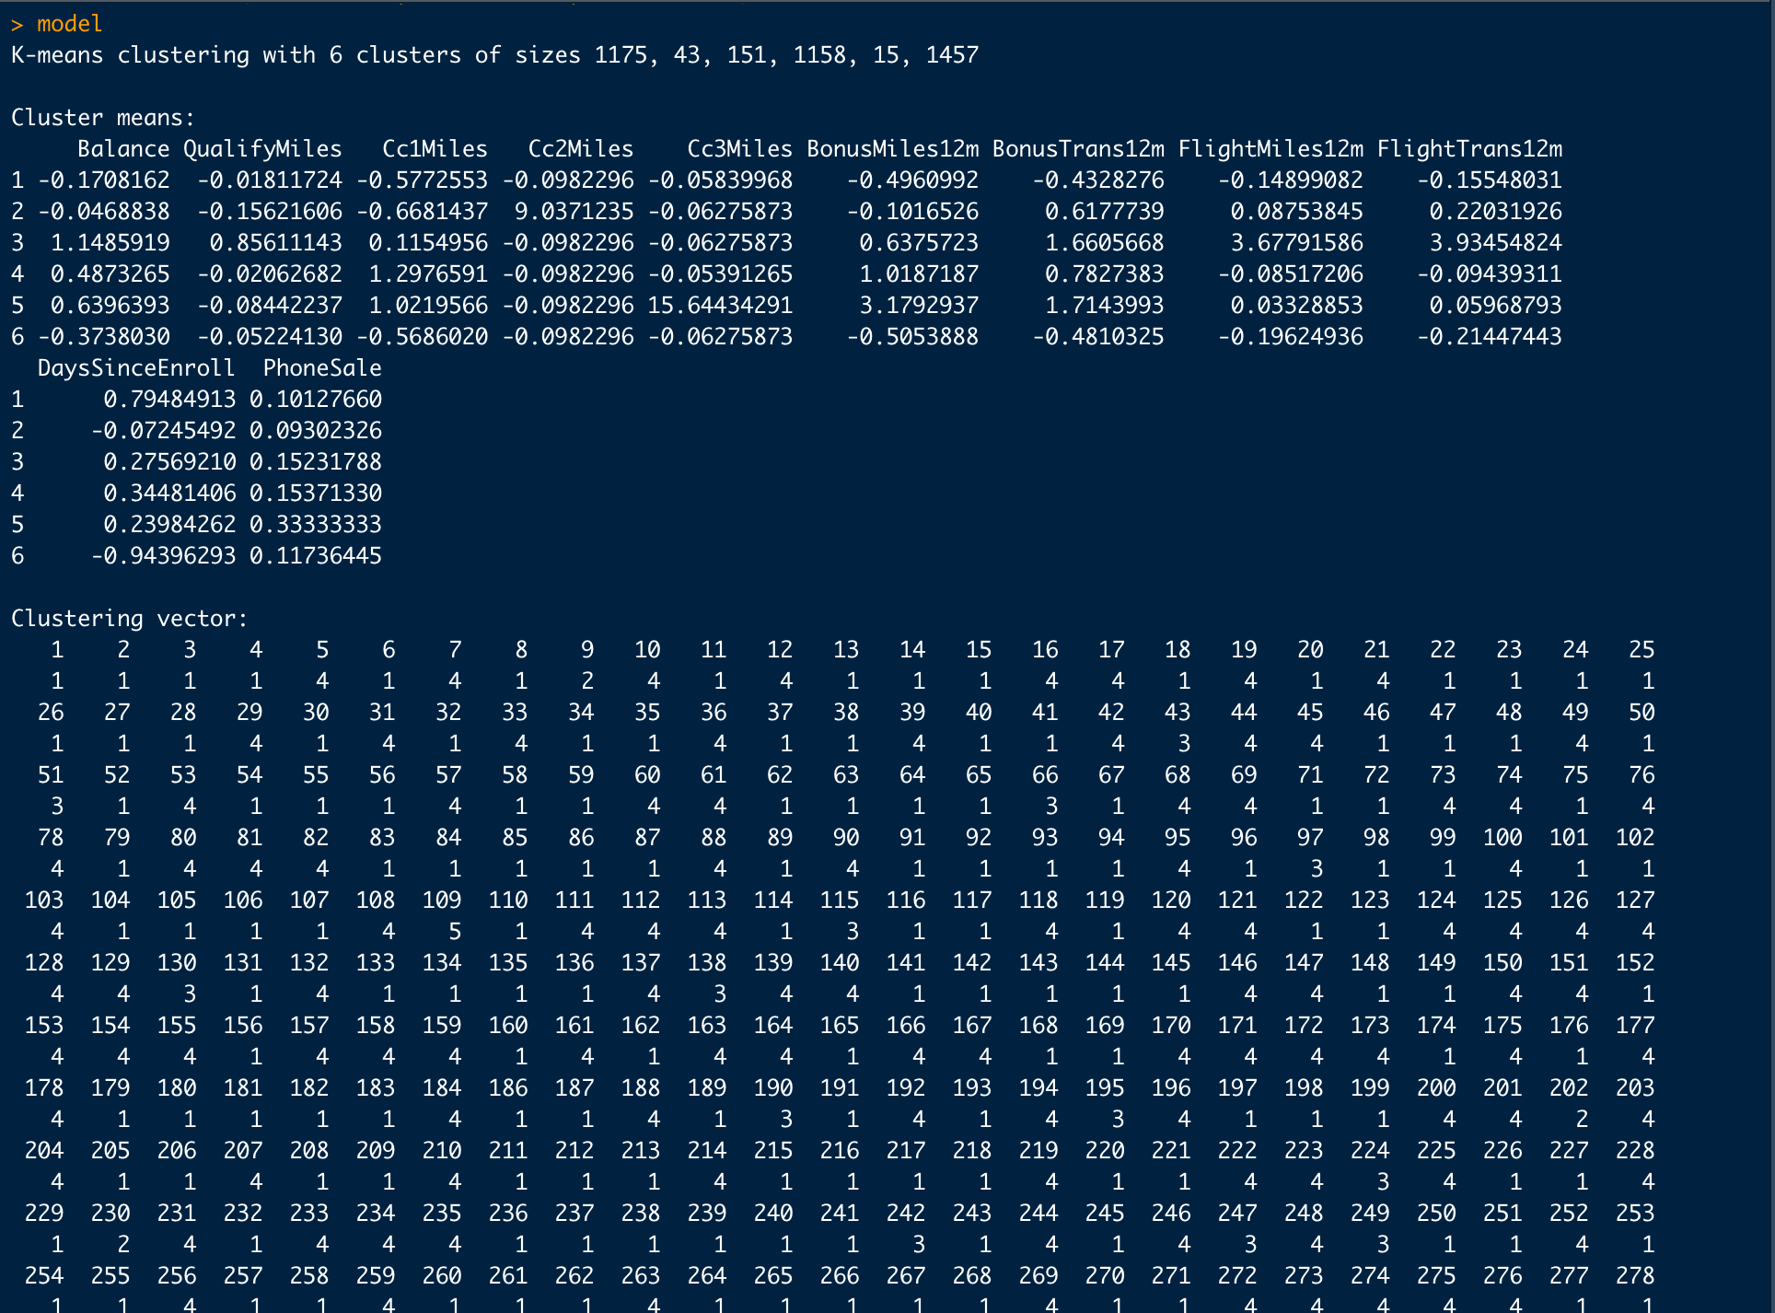

1. Plot a histogram to show the frequency of each cluster (for each cluster, visually show the number of data points clustered into it).

**Answer: Input**

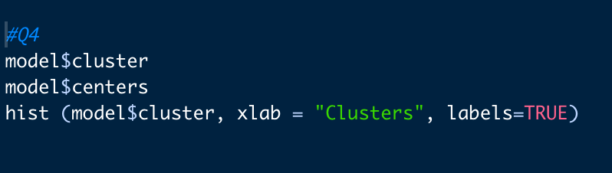

**Output:**

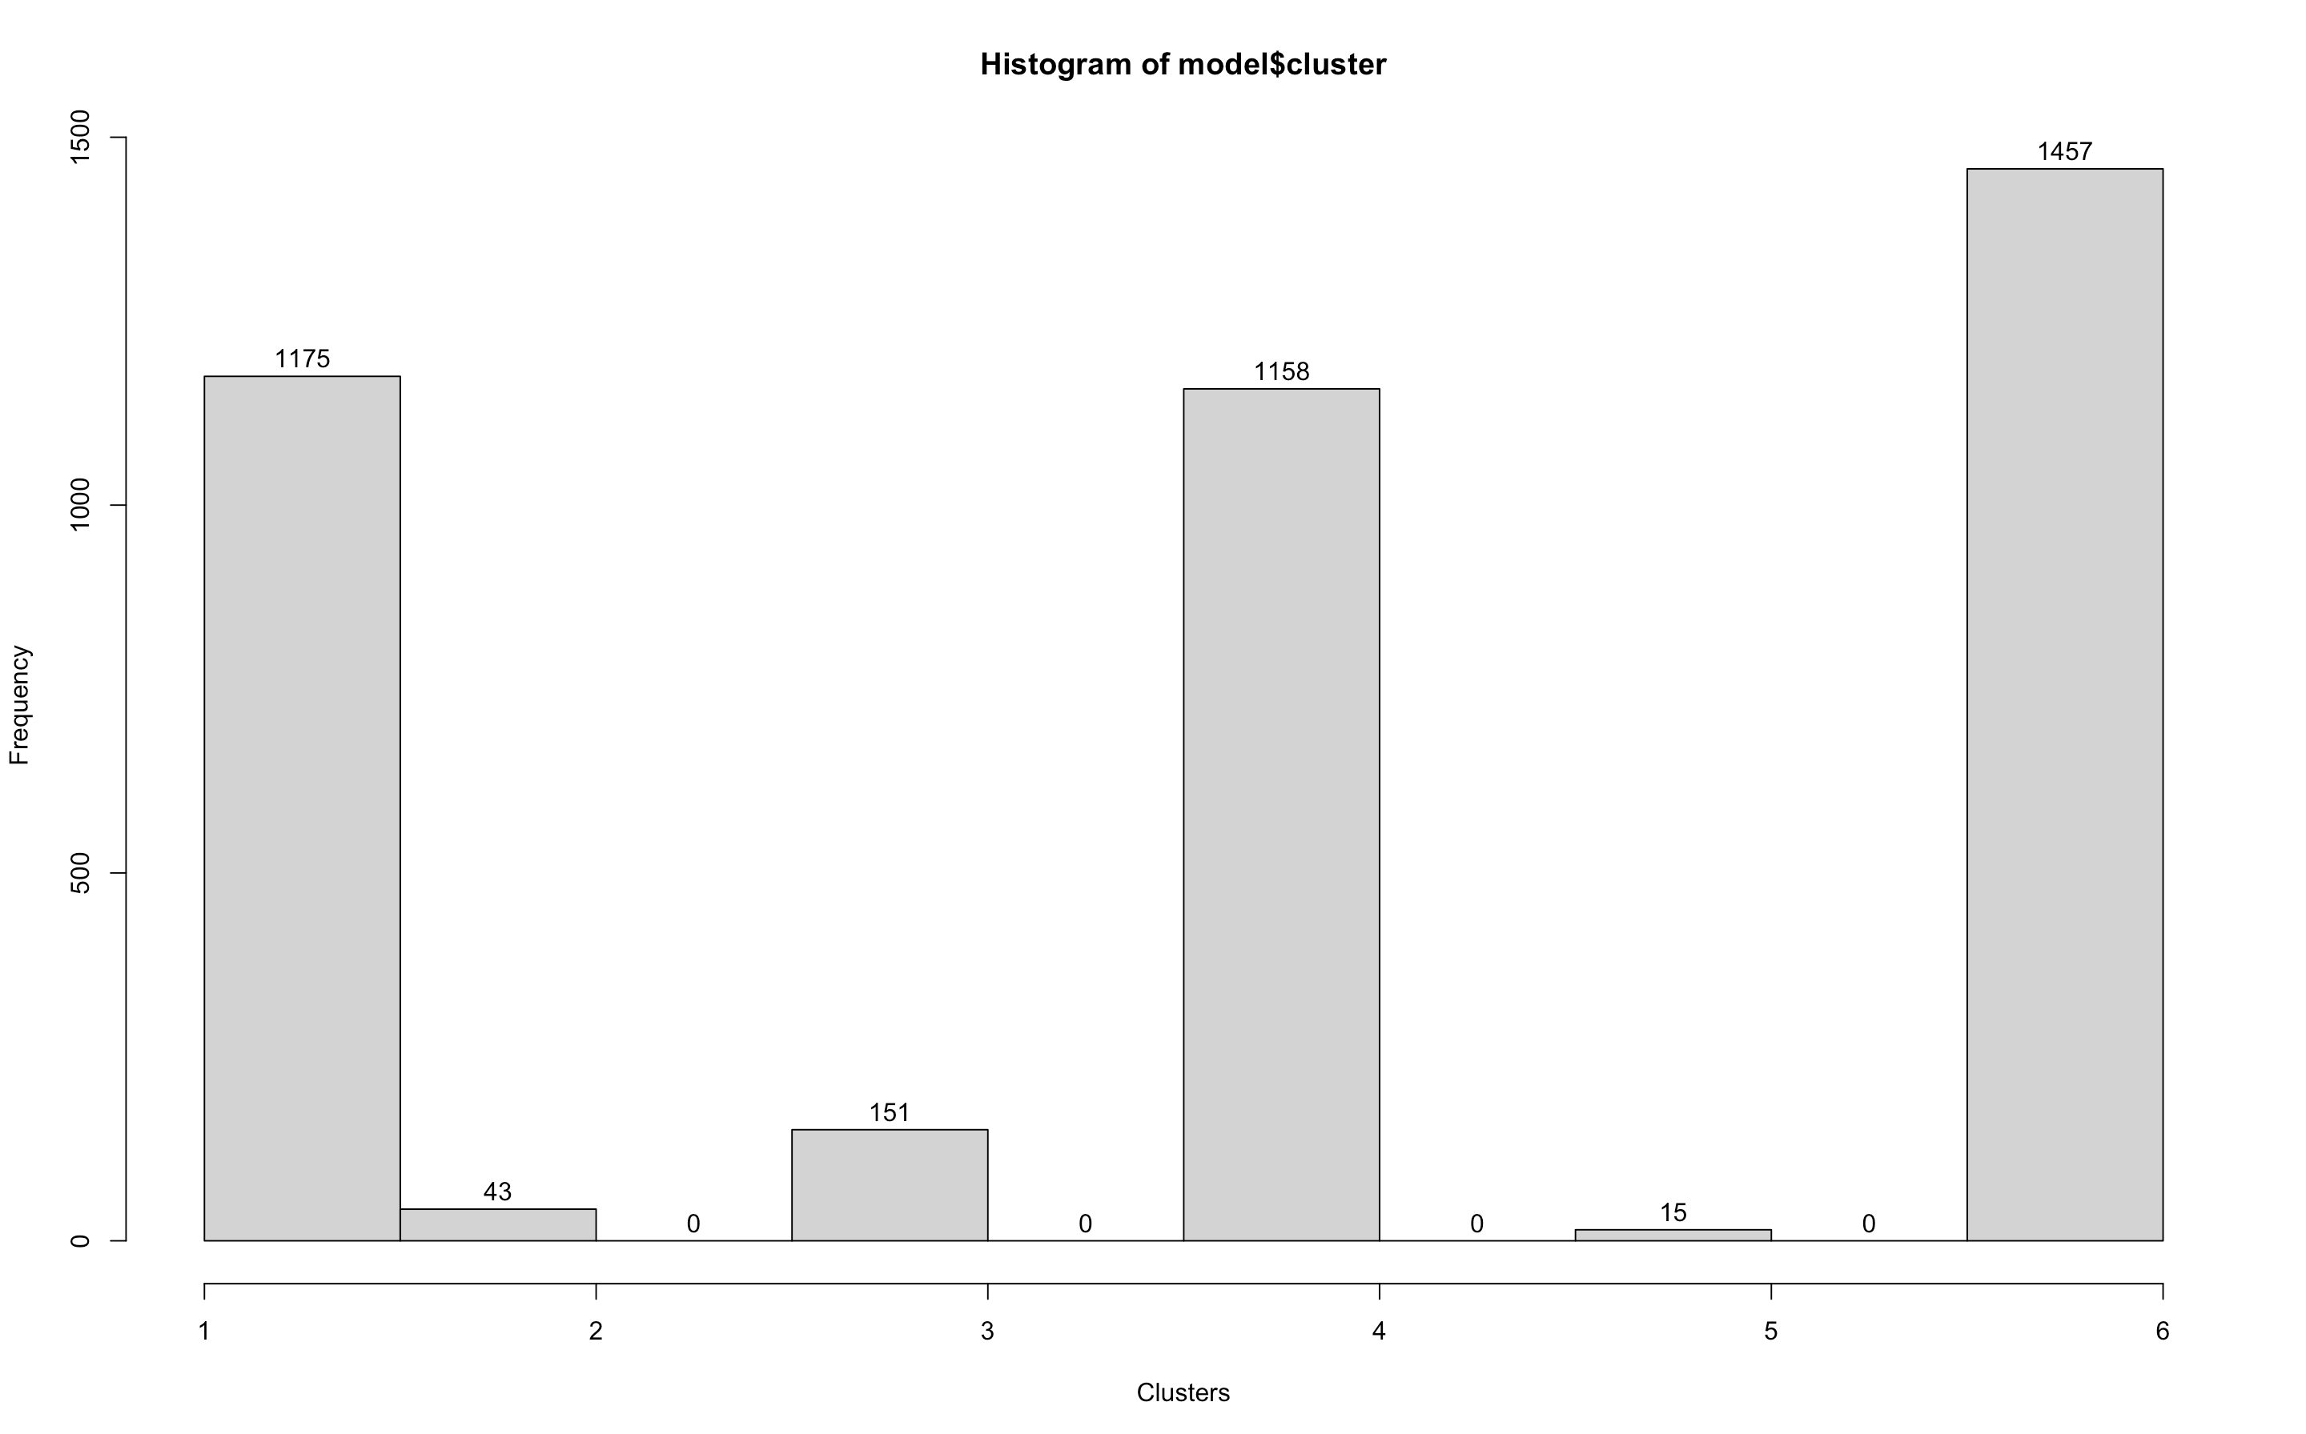

1. Create a dummy variable for each cluster and predict the PhoneSale using a logistic regression. Answer what cluster has the highest probability to purchase and what cluster has the lowest probability to purchase (assume the coefficient estimates are all statistically significant). Finally answer what is the most prominent feature for the customers in the high purchase probability cluster. If you were the marketing manager, what kind of customers would you focus on?

**Answer: Input**

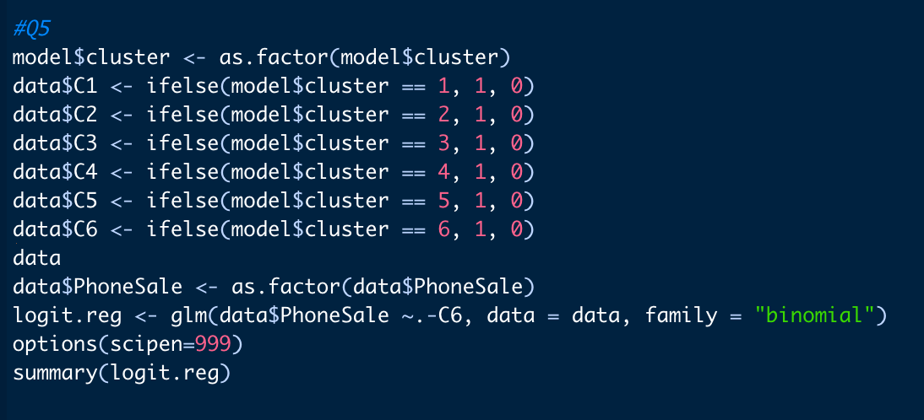

**Output:**

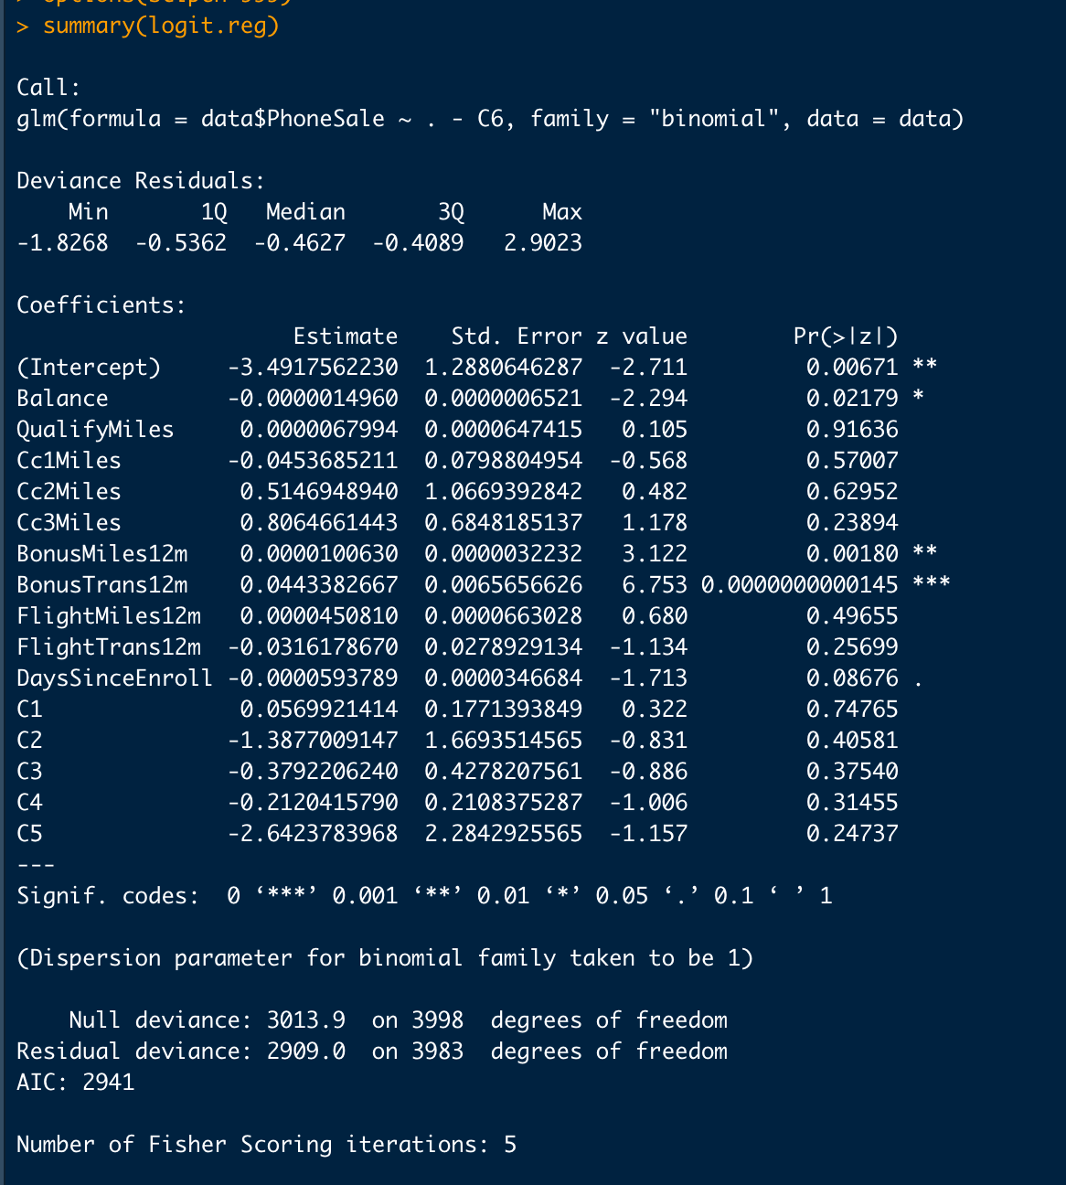

**Baseline is Cluster 6. We can see from the findings that Cluster 1 has the highest possibility of being purchased, while Cluster 5 has the lowest probability.**

**Given that BonusTrans12ms (Number of non-flight bonus transactions in the last 12 months) has a statistically significant p value, it is the most crucial feature in cluster 1 (higher probability cluster).**

**The manager needs to concentrate on the clients who have a higher volume of these non-flight bonus transactions.**